Chapter 14: Answers
Consolidation and analysis
- Bivariate tests examine the relationship between two variables only and these can be any variables.
- Multivariate tests are used when there are two or more dependant variables simultaneously. Hypothesis testing is a process employed to make decisions about a population based on sample data. It involves formulating two competing statements about a population parameter and using statistical tools to arrive at a conclusion.
- The steps in hypothesis testing are as follows:
- Specify a hypothesis
- Specify the level of risk
- Decide on appropriate statistical technique
- Run the technique
- Interpret the results
- Reach a conclusion based on the results.
- The level of error in hypothesis testing (the alpha level, usually 0.05) is the probability of rejecting the null hypothesis when it is actually true (Type I error). We use it as a cutoff: if the p-value is less than alpha, we reject the null hypothesis; if the p-value is greater than alpha, we fail to reject it.
- Correlation assesses the linear relationship between two variables with no causal chain implied between the two.
- Regression focuses on prediction where one or more IVs are used to predict outcomes in the DV. Linearity means that the relationship between variables can be seen as a straight line. This can be observed through scatterplots.
- Multiple regression is an extension of simple linear regression and allows for the prediction of a single continuous DV using two or more IVs.
- We use an independent samples t test when we compare the means of two independent groups.
- We use an independent samples t test when we are comparing two groups that are unrelated whereas a paired samples t test compares the means of two sets of observations that are related.
- We assess the effect size of
  - Regression (R-squared)
Note: We can also measure the effect size using the percentage of the variance between the two variables. We do this by squaring the correlation coefficient or calculating r-squared (r2). This is also called the coefficient of determination. This can be confusing to interpret so we convert this value into a percentage.
It is important to note here that this does not mean that self-efficacy causes the percentage change in statistics confidence and vice versa. Rather, this tells you that the percentage of the variation in stats confidence can be explained by self-efficacy.
  - Independent samples t test (Cohen's d)
  - ANOVA (Eta-squared)
  - Chi square (Phi or Cramer's V)
- Post-hoc tests are procedures performed after an omnibus (i.e., ANOVA) test in cases where the omnibus test's null hypothesis has been rejected. They tell us which particular group means differ significantly from each other.
- We would use a two-way ANOVA when we want to assess the effect of two categorical IVs on a single continuous DV.

Application
- A researcher is interested in investigating the association between gender (male, female) and choice of degree (BA, BCom, BEng, BSc, MBBCh)
  - The variables in this study are gender and choice of degree.
  - The scale of measure for the variables: Both are nominal.
  - The hypotheses that frame this study are:
    - Null hypothesis: There is no association (or no statistically significant relationship) between gender and the choice of degree.
    - Alternative hypothesis: There is an association (or a statistically significant relationship) between gender and the choice of degree.
  - This study can be investigated by obtaining a representative sample of university students from various degree programmes. A random sampling method is ideal to ensure generalisability. Data must be collected on two pieces of information from each participant: their gender (male or female) and their chosen degree (BA, BCom, BEng, BSc, MBBCh).
  - They should use a Chi-square test as the objective is to assess the association between two categorical variables.
- Practice dataset: responses
  - There is no significant correlation between age and self-efficacy (r = -.016; p = .645)
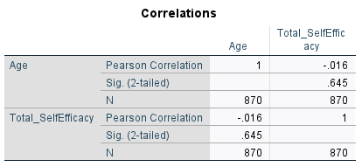

  - Age is not a significant predictor of self-efficacy (B = -.061; p = .645)

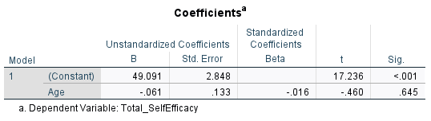
  - There is a significant difference in age between students across faculties at the 0.05 level of significance (F = 2.552; p = .026)
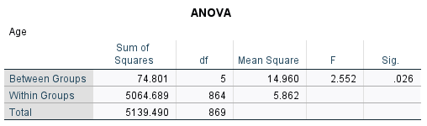
  - There is no association between an individual’s gender and the faculty they belong to (Χ² = 11.242; p = .728)

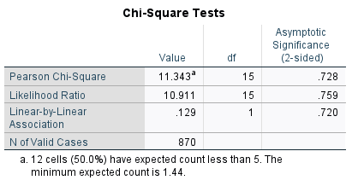
Self-reflection
- A study finds that a new teaching method improves test scores by an average of 1.2 points (on a 100-point scale) compared to the traditional method, and this difference is statistically significant (p < .05). Based on this, do you think the result is practically significant? Why or why not? What does this scenario teach you about the difference between statistical and practical significance?

This will probably not be practically significant. An average improvement of 1.2 points on a 100-point scale is very small and even though the result is statistically significant, it may not make a meaningful difference in real-world teaching or student performance. Statistical significance shows that the result is unlikely due to chance, especially with large samples, but it does not indicate how important or useful the effect is. This example shows that a result can be statistically significant yet have little practical value. Practical significance depends on the size of the effect and whether it is large enough to matter in real-life contexts and not just whether it is unlikely to occur by chance.

- A large-scale study finds that a new therapy reduces depression scores by 1.5 points on a standard 50-point depression scale, and this result is statistically significant (p < .05). Do you think this result is practically significant? Why or why not? What does this scenario teach you about the difference between statistical and practical significance?
This result could be practically significant or not. A 1.5-point reduction on a 50-point depression scale is statistically significant but may appear small in absolute terms. However, its practical significance depends on how the scale is interpreted clinically. Many depression measures use cut-off scores to classify severity levels (e.g., mild, moderate, severe). If a 1.5-point change moves a person across a cut-off (for example, from severe to moderate depression), the change could be clinically meaningful even if it seems numerically small. This would warrant further investigation into how many participants crossed such thresholds. This example shows that statistical significance indicates reliability of an effect, while practical or clinical significance reflects real-world impact. A small average change may be unimportant for some individuals but critical for others, depending on its implications for diagnosis, treatment decisions, and functioning.

