Chapter 13: Answers
Consolidation and analysis
- Descriptive statistics summarise and organise data to enable us to understand what is happening in a sample.
Inferential statistics use sample data to make predictions or generalisations about a larger population.

- Categorical variables represent discrete groups or categories with no inherent numerical order (e.g., gender).
Continuous variables can take on any numeric value within a range and allow for meaningful mathematical operations (e.g., age).

- A dichotomous variable has only two categories (e.g., yes/no, male/female, pass/fail). It is a type of categorical variable.

- The four levels of measurement are:
- Nominal level: Categories with no numeric meaning or order (e.g., gender).
- Ordinal level: Categories that have a meaningful order (e.g., year of study).
- Interval level: Values with no true zero (e.g., temperature in Celsius).
- Ratio level: Continuous values with a true zero point that which allow all mathematical operations (e.g., height, weight, reaction time).

- The measures of central tendency are mean, median, and mode, which describe the centre or the typical value of a distribution.

- Measures of variability, such as range, variance, and standard deviation, describe how spread out or dispersed the data are around the centre. They are important because they show how consistent or variable the scores are, which allows the researcher to interpret the meaning of averages and compare different datasets accurately.

- Range is not the best measure of spread because it is based only on the highest and lowest values, making it highly sensitive to outliers.

- A normal distribution is a symmetrical, bell-shaped distribution where most values cluster around the mean and probabilities follow a predictable pattern. It is important in inferential statistics because many statistical tests assume normality.

- The median is more useful when a dataset is skewed or contains outliers because it represents the middle value and is not pulled in the direction of extreme scores.

Application
- Identify the DV in the following statements:
- Intelligence has an effect on self-esteem. (self-esteem)
- Mode of testing influences test performance. (test performance)
- There is a relationship between religiosity and stress. (no disenable DV)
- Religiosity influences stress level. (stress level)
- Stress levels influence religiosity. (religiosity)

- Which is the IV in the following statements:
- Sense of coherence influences intention to emigrate. (sense of coherence)
- There is a relationship between shiftwork and work performance. (no disenable IV)
- Gender has an impact on emotional intelligence. (gender)
- Work motivation is influenced by remuneration. (remuneration)
- Socio-economic status is related to xenophobic perceptions. (no disenable IV)

- Identify the scales of measure in the following:
- I.Q. scores. (continuous)
- Jersey numbers of a sports team. (categorical)
- Judges’ ratings in determining preference for a particular product. (categorical)
- Types of tertiary educational institutions. (categorical)
- Personality scores on the NEO-PI. (continuous)
- Political parties in an election. (categorical)

- In terms of levels of measurement, what would you classify the following variables as:
- Years of study (1st, 2nd, 3rd, and so on). (ordinal)
- Religious groupings (Christianity, Hinduism, Islam, Judaism, Other) (nominal)
- Statistics experience (Beginner, Intermediate, High). (ordinal)
- Statistics experience (rated from 1 – low to 5 – high). (ordinal)
- Statistics experience total calculated on a scale with scores ranging from 0–50. (interval)

- Display the variable “Faculty” as a pie chart and provide a brief interpretation.
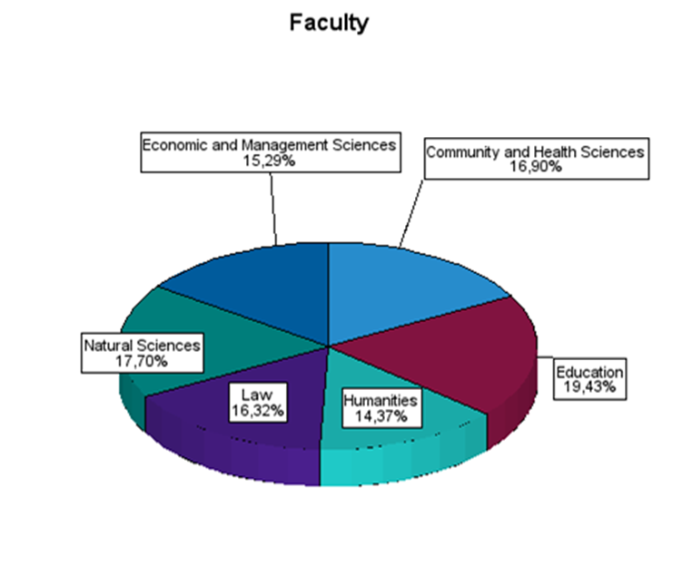
All six faculties are represented in the pie chart. The highest percentage of the students are from the Faculty of Education (19.43%). The faculty with the least number of students who participated in the study was the Faculty of Humanities with 14.73%.
- The sample size is 30.

- Normality:
Set A: The mean, median, and mode are very close (5.1, 5, 5), which suggests an approximately normal distribution.

Set B: The mean is higher than the median and mode (2.7 vs. 2 and 1), which suggests a positively skewed distribution.

Set C: The mean, median, and mode are close (7.6, 8, 8), which suggests an approximately normal distribution.

Range:
All three datasets have the same range (1 to 10), even though their distributions differ.
This shows that range is not a good measure of spread because:
- It only uses the maximum and minimum values.
- It does not reflect the shape or variability of the data inside the distribution.

- Interpretation of “Age”
The participants’ ages range from 1 to 37 years, with an average age of 24.18 and a standard deviation of 8.00. This indicates moderate variability in the sample. The skewness value of –0.96 suggests a negatively skewed distribution, which means that more participants are older than the mean, and there are fewer younger participants. This skewness indicates that age is not normally distributed, which has implications for statistical analyses that assume normality.
Interpretation of “Depression”
The depression scores range from 0 to 45, with a mean of 19.35 and a standard deviation of 10.63. This reflects substantial variability in depression symptoms. The skewness value of 0.11 is very close to zero, suggesting that the distribution is approximately symmetrical and, therefore, closer to normality. This makes the depression variable more suitable for statistical procedures that assume a normal distribution.

- The sample includes 870 participants, with self-efficacy scores ranging from 19 to 72, giving a range of 53. This indicates a substantial spread in participants’ levels of self-efficacy. The mean score of 47.79 and the standard deviation of 9.52 suggest moderate variability around the average, which means that participants differ considerably in how confident they feel in their abilities.
The skewness value of –0.237 is very close to zero, indicating that the distribution is approximately symmetrical, and the kurtosis value of –0.375 suggests a slightly flatter-than-normal distribution. Taken together, these values imply that the Total Self-Efficacy scores are reasonably close to normal, making the data suitable for analyses that assume normality.
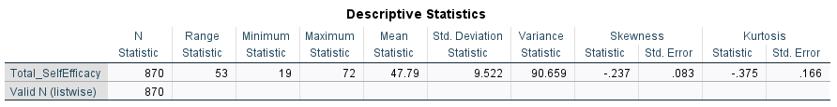

Self-reflection
- Measures of central tendency and variability are not appropriate for categorical variables such as gender because these variables have no numerical meaning or inherent order, making averages or dispersion statistics uninterpretable. Categorical data should be summarised using frequencies and percentages, which accurately reflect how many individuals fall into each category.

