Zuko’s Keys – Plot the action

Name of learner: ___________________________________________________________________

Read through the play carefully and complete the action plot of the play.

Scene | What happens in the scene? | Where and when is the scene taking place? | Who is involved in the action?
ACT 1
1
2
3
4
5

Scene | What happens in the scene? | Where and when is the scene taking place? | Who is involved in the action?
ACT 2
1
2
3
4
ACT 3
1
2
3
4
5

Zuko’s Keys – Character chart

Name of learner: ___________________________________________________________________

Read through the play carefully and draw up the character chart below.

 | Zuko | Hilda & Matilda | Mandla | Sweetness  and Jojo | The Gang of Three
What you learn about the character(s) from what he/she says (they say)
What you learn about the character(s) from what the other characters say
What you learn about the character(s) from his/her (their) actions
What you learn about the character(s) from how the other characters react to his/her (their) actions
Drama report

Title of drama: ________________________________

Cast of characters: ___________________________________________________________________________

__________________________________________________________________________________________

Setting: ____________________________________________________________________________________

__________________________________________________________________________________________

Describe what happens in the beginning of the drama: _______________________________________________

__________________________________________________________________________________________

__________________________________________________________________________________________

__________________________________________________________________________________________

Describe what happens in the middle of the drama: _________________________________________________

__________________________________________________________________________________________

__________________________________________________________________________________________

__________________________________________________________________________________________

Describe how you think the drama ends: __________________________________________________________

__________________________________________________________________________________________

__________________________________________________________________________________________

__________________________________________________________________________________________

Give the play a rating out of 5: ______________________
Folktales: Follow the plot

Name of learner: ___________________________________________________________________

Title of folktale: ____________________________________________________________________

Setting

Main Characters

Actions or events in the story

1

2

3

Conflict and resolution

1

2

3

Folktales: Actions and reactions

Name of learner: __________________________________________________________________________

Select an incident or event in the folktale and analyse it.

Title of the folktale: ___________________________________________________________________________

The incident/event: ___________________________________________________________________________

__________________________________________________________________________________________

Characters involved in the interaction: ____________________________________________________________

__________________________________________________________________________________________

The reaction of the other character/s to the initial action/words said: ____________________________________

__________________________________________________________________________________________

__________________________________________________________________________________________

__________________________________________________________________________________________

The result of the interaction: ___________________________________________________________________

__________________________________________________________________________________________

How it affected the plot of the folktale: ____________________________________________________________

__________________________________________________________________________________________

__________________________________________________________________________________________

__________________________________________________________________________________________

Folktales: Characters

Name of learner: ___________________________________________________________________

Complete the character chart below for the folktale _________________________________________

Character | Person/Animal  Physical Appearance | What you know about the character from his/her actions | Impact the character has on the story
Folktales: Identify the theme and the lesson

Name of learner: ___________________________________________________________________

Title of folktale: ____________________________________________________________________

___________________________________________________________________________

___________________________________________________________________________

___________________________________________________________________________

___________________________________________________________________________

___________________________________________________________________________

Theme

Lesson

___________________________________________________________________________

___________________________________________________________________________

___________________________________________________________________________

___________________________________________________________________________

___________________________________________________________________________

Mood and tone in poetry

Name of learner: ___________________________________________________________________

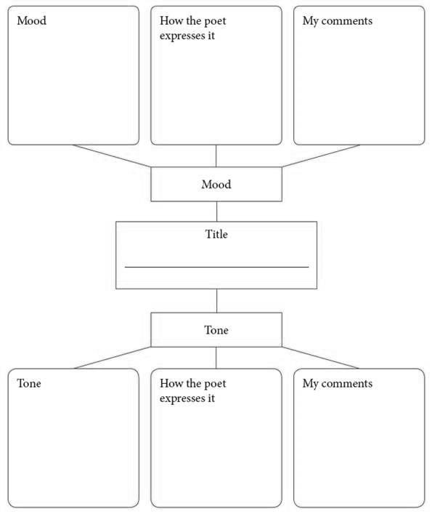

Analysis chart

Title of poem: ______________________________________________________________________

Element | Evident in poem
External structure
Internal structure
Examples of figurative language
Theme
Message
Identifying figurative language

Name of learner: ___________________________________________________________________

Once you have read the lines from the poem, decide which figure of speech is being used, write it down and explain how you reached your answer.

1. Silence, then slowly, with the sinking sun
(The Hunting of Shumba by Kingsley Fairbridge)

Figure of speech: ___________________

Write a sentence explaining your answer. _____________________________________________________

______________________________________________________________________________________

2. Spring is like a perhaps hand
(Spring is like a perhaps hand by ee cummings)

Figure of speech: ___________________

Write a sentence explaining your answer. _____________________________________________________

______________________________________________________________________________________

3. What would you do, if you were me, / To prove that you were you?
(The Twins by Henry Sambrooke Leigh)

Figure of speech: ___________________

Write a sentence explaining your answer. _____________________________________________________

______________________________________________________________________________________

4. Where Reason makes kites of her laws and flies them,
(Baby’s World by Rabindranath Tagore)

Figure of speech: ___________________

Write a sentence explaining your answer. _____________________________________________________

______________________________________________________________________________________

Story summary

Name of learner: __________________________________________________________________

Story title: _____________________________

Author: _______________________________

Pages: _______________________________

Genre: _______________________________

This is a five sentence summary of the plot of this story: _________________________________________

__________________________________________________________________________________________

__________________________________________________________________________________________

__________________________________________________________________________________________

__________________________________________________________________________________________

__________________________________________________________________________________________

The author’s purpose for writing this story was: _________________________________________________

__________________________________________________________________________________________

__________________________________________________________________________________________

__________________________________________________________________________________________

The audience that the author wrote this story for is: _____________________________________________

__________________________________________________________________________________________

__________________________________________________________________________________________

A cause and effect relationship in this story:

This event/decision: ________________________________________________________________________

Caused this to happen: _____________________________________________________________________

Story Map 1

Title of the story: __________________________________________________________________

Directions: Fill in the required information in each section below as indicated. Be as specific as you can in each section.

Setting:

Characters:

Problem/Conflict:

Plot (number individual events as they occur and identify which event is the climax
of the story):

Resolution:

Story Map 2

Title of the story: __________________________________________________________________

Directions: Fill in the required information in each section below as indicated. Be as specific as you can in each section.

Setting:

Characters:

Problem/Conflict:

Event 1

Event 2

Event 3
Plot

Climax

Resolution

