Term 3 Assessment 6
Test: Economic geography
This unseen test should take 45 minutes to complete.
The mark out of 50 can be scaled down to a mark out of 10 by dividing it by 5.
This mark out of 10 can then be used as the test mark for the Programme of Assessment.

Question 1
1.1 Copy and complete the following table.
Provide descriptions and an example of each of the four economic sectors. (4 × 2) (8)

Economic activity | Description | Examples
Primary
Secondary
Tertiary
Quaternary

1.2 What is the difference between small-scale and large-scale farming? (4 × 2) (8)

1.3 Describe how beneficiation has impacted on the contribution of mining to
South Africa’s economy. (3 × 2) (6)
[22]
Question 2
Define the following concepts:
2.1.1 Heavy industry (1 × 2) (2)
2.1.2 Light industry (1 × 2) (2)

2.2 What is an ubiquitous industry? (1 × 2) (2)

2.3 Name TWO key objectives for creating IDZs. (2 × 2) (4)

2.4 Name TWO problems associated with industrial centralisation. (2 × 2) (4)

2.5 Provide ONE solution to the problems caused by industrial centralisation. (1 × 2) (2)
[16]
Question 3
Study the map below and then answer the questions that follow.
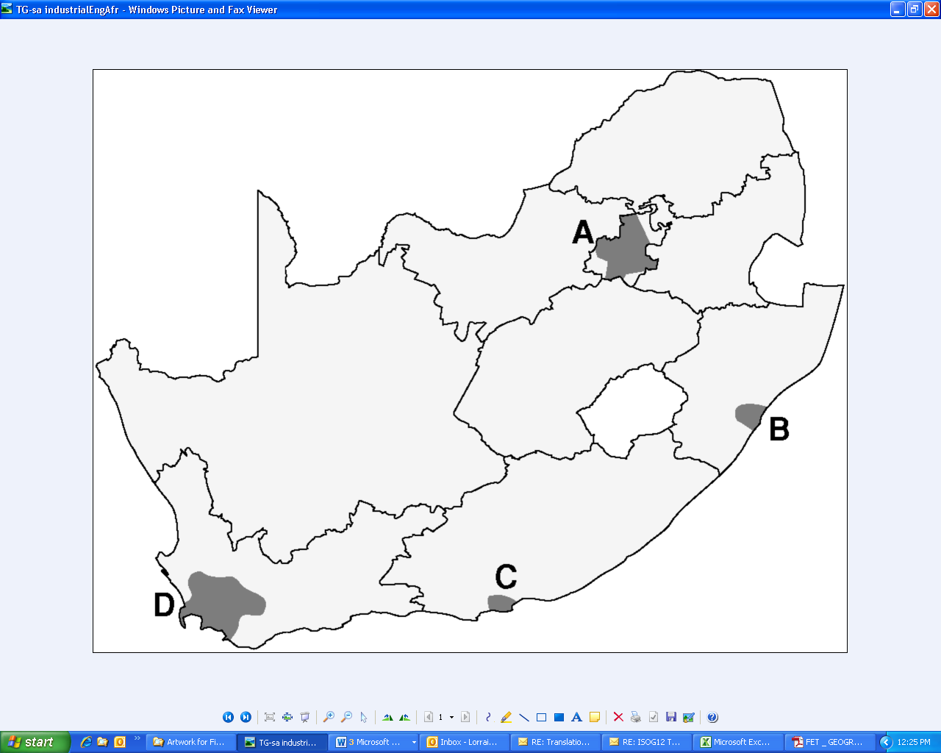

3.1 Identify the industrial areas marked A, B, C and D respectively. (4 × 1) (4)

3.2 Provide TWO factors that promote Industry at A. (2 × 2) (4)

3.3 State the main type of industry found at C. (1 × 2) (2)

3.4 Name the large IDZ located near to C. (2)
[12]

Total 50 marks

