Term 2 Assessment 3
Mapwork task – Suggested answers
1 Comparison between two types of settlement:
Grid reference | C2 | A3 | Marks
Settlement type | Nucleated rural settlement✓ | Dispersed rural settlement✓ | (1 + 1) (2)
Description | Individual households clustered together within the meander of the river✓, adjacent to cultivated fields and a sand footpath✓. This cluster of households could be a collection of labourers' cottages on a farm✓ (any two points) | Individual households dispersed across the landscape✓, located on sand footpaths on the south-facing slopes of the hill✓ | (2 + 2) (4)
Benefits to household residents | Households share services and facilities✓, more secure✓, village will have communal governance system✓ (any two points) | Households can control their own decision making✓, have access to more space and land✓ | (2 + 2) (4)
Disadvantages | Households cannot make independent decisions; farmers have to farm communally✓ | Less secure, cannot share services and facilities✓ | (1 + 1) (2)
(sub-total for this question) (12)

2 Type: Nelspruit is an urban settlement✓✓
Reasons – It is a large service centre✓ as it contains a hospital✓, a large number of schools✓ and churches✓, a police station✓ and a post office✓. It has an industrial area✓, large roads and a station at the intersection of two main railway lines✓, and residential suburbs✓ (any three points). (2) + (3 × 2) (8)
3 Site: Nelspruit is located on the Crocodile River✓ on a relatively narrow floodplain✓ but it has grown to extend onto the surrounding slopes. The site✓ covers mostly hilly landscape at between 200 and 600 m above sea level✓
Situation: The city is situated at a transport node✓, the intersection of the N2✓ and the R40✓ and along a major railway line✓. Nelspruit is centrally situated✓ within a large agricultural✓ or farming area and functions as a service centre✓ and transport node✓ (any three points). (2 × 2) + (4 × 2) (12)
4 Description: Nelspruit has developed in three sectors✓ that radiate outwards from the central route intersection✓.
Account for the urban form: Nelspruit has developed along major transport routes✓ and the Crocodile River, curving along its meanders✓. Sonheuwel, the mountain to the south of the town, divides the two biggest sectors✓, one extending south eastward and the other south westward. (2) + (3 × 2) (8)
5.1 Learners draw a labelled cross-section from west to east, which shows the topography of Sonheuwel and they label the significant features on the cross section. (15 × 2) (30)
5.2 The cross-section provides information on the shape and form of Sonheuwel✓ which has been a barrier to urban development✓ as the suburbs of Nelspruit have developed around it as it is too steep for urban development✓. (3 × 2) (6)
6 Matafin is small rural service centre✓✓.
Individual buildings show that the rural settlement is nucleated but has a low density✓✓. It has developed around a station✓✓ and contains the Ethel Frayne clinic✓✓. (2) + (2 × 2) (6)
7 Nelindja is an urban✓, nucleated✓, high density residential suburb✓✓ of Nelspruit.
It is located close to the industrial area✓ on the outskirts of the town✓ which is typical of the location of segregated townships✓ during the apartheid era. It has an irregular road pattern✓ and the schools and churches are located outside of the settlement✓ and therefore it does not have many services and facilities within it which is typical of township development✓ (any two points). (2 × 2) + (2 × 2) (8)

8.1 Sewerage works✓✓
This is located on the outskirts of the town✓ near the industrial area as these services are considered as having negative impacts on people✓ and hence it is not located near a higher income residential suburb✓. It cannot be too far from the town as it is expensive to transport sewerage over long distances✓. It is located near the river as the sewerage works needs water to function✓ and the treated sewerage is released back into the river✓ (any two points).
(2) + (2 × 2) (6)
8.2 Quarries✓✓
The stone✓ excavated✓ from these quarries would have been used to construct the road✓ (any two points). (2) + (2 × 2) (6)
8.3 This is an electrical sub-station✓✓.
Buildings have been developed to manage these high voltage power lines✓ and the transformers that direct power towards Nelspruit✓. This sub-station is located on a railway line✓ near a station as it may need heavy materials transported to the site by rail✓ (any two points). (2) + (2 × 2) (6)
9.1 NW - 25°28´S;✓ 30°58´E✓,
NE - 25°28´S;✓ 30°59´E✓,
SW - 25°29´S;✓ 30°58´E✓,
SE - 25°29´S;✓ 30°59´E✓ (4 × 2) (8)
9.2 This area contains the high order functions✓ of the town such as the police station✓, the post office✓ and many churches✓. It is centrally located✓ on the N4 and has a grid pattern✓. The orthophoto shows the large buildings that are present in the CBD✓(any four points).
(4 × 2) (8)
10 Economic activity is trade and commerce✓✓.
Large shopping centre has a large roof area✓, large parking lot✓ and is located with good access to the N4✓ (any two points).
(2) + (2 × 2) (6)
11 Heavy and light industry✓✓
Located on flat land✓ on the outskirts of the town✓. (2 + 2) (4)
12 The land use around the Nelspruit hospital is open space with trees✓. There are no other urban activities in close proximity to the hospital✓
(2 + 2) (4)
13 Urban challenges: employment✓, containing sprawl of the town✓ as it does not have a compact urban form✓ due to topography and location of the town along main transport routes✓, upgrading of the Nelindja township✓ and integration of this township in to the main urban area, may need to deal with flooding from the Crocodile River✓ (any two points).
Rural challenges: employment✓, providing services to dispersed rural settlements✓, upgrading roads as many people use footpaths✓, may need to address land claims✓, management of the quality of water in the Crocodile River due to rural and urban pollution✓ (any two points).
(2 × 2) + (2 × 2) (8)
14 Nelspruit offers higher level facilities✓.
It has many schools✓, a golf course✓, many churches✓ and shopping facilities✓ (any three points). (1 + 3) (4)
15 The site characteristics of Nelspruit are that it is a wet point settlement because it is located on a river and it is also at the junction of a number of transport routes so its site has been determined by where these transport routes meet.
If the learners use the maps in the Learner's Book then Graaff-Reinet✓✓ has very similar site characteristics to Nelspruit as it is also located on a river and it has developed where a number of transport routes converge✓✓. The site of Richards Bay✓✓ is similar to Nelspruit in that the town has developed at a port and hence its site has been determined by being at the convergence of major transport routes✓✓.
Other answers from the Learner's Book include the much smaller rural settlement at Mukukwini near Oliviershoek is a wet point settlement and its site has been determined by the Thukela River. (The formal settlement on this map has been developed as part of the Vaal- Thukela Water Scheme and so it has been influenced by the presence of a large water source, the Sterkfontein Dam.) Although there is a river close to Marikana, the site of this settlement has been determined by the location of platinum deposits.
If learners use an atlas they can identify other towns in South Africa that have developed because of water being in close proximity or at a point where there is a convergence of transport routes. (2 × 2) + (2 × 2) (8)
16 Nelspruit is a service centre. It therefore contains functions that are typical of a service centre such as a police station, shops, churches, schools, library, municipal offices, magistrates court, etc. It is also a transport centre as it has developed where a number of major transport routes converge.
Bethlehem ✓✓, which is provided as an example on page 120 has a similar size and set of functions✓✓ as Nelspruit. Graaff-Reinet✓✓ is smaller than Nelspruit but it has similar functions as it is a service centre that is located on major transport routes with an agricultural hinterland✓✓ (if using atlases learners may select any two places with the correct justification). (2 × 2) + (2 × 2) (8)
17 Vector models use vectors or directional lines✓ to show a geographic feature. Vector data has a sequence of vertices✓ that define a line segment. Each vertex has an x and a y co-ordinate✓. Each string of vertices starts and ends with a node✓. Point features have one co-ordinate pair, a vertex✓. A polygon has a set of closed co-ordinate pairs✓. The storage of each vertex and the connectivity between vertices is important in GIS✓ (any three points).
Raster data models use a grid-cell✓ data structure where the geographic area is divided into cells✓ identified by row and column✓. This forms a tessellated data structure. The user chooses the size of cells in the structure, based on the data accuracy and resolution✓ that he or she needs. The geographic co-ordinates are stored in the layout of each of the cells and so there are no points that are spatially referenced✓. The data is usually divided into regularly spaced cells, with each cell the same shape and size✓. Squares are most commonly used✓ (any three points).
(3 + 3) (6)
18 Both: Figure 3.79 is an example of raster✓✓ data as it is an aerial photograph that is made up of millions of tiles or pixels✓✓ that form the image of the photograph. It is also an example of a vector image✓✓ as the contour lines and the grid lines that are part of the orthophoto map are vector lines or vector data that are geo-referenced✓✓.
(2 × 2) + (2 × 2) (8)
19.1 Learners must identify the broad land use zones listed and use tracing paper to draw a polygon shape around each specific land use area. They must shade each different land use polygon a different colour and must provide a key. The map they produce should be similar to the one shown on page 106 in the Teacher's Guide but they may select fewer areas (for example fewer recreation areas). Give credit for any eight correctly selected polygons and for overall neatness and accuracy.
(8 × 2) + (4) (20)
19.2 Leaners must produce a table with at least eight rows, one for each land use zone and three columns as shown in the following example. They must populate the table based on their assessment of each land use zone. They may have more than one polygon that is in a particular category of land use, and each polygon should have its own co-ordinate
identification (ID).

ID  ✓ ✓ ✓ | Land use zone  ✓ | Value of Property  ✓
25°27´50˝S; 25°57´40˝E | Industrial | Medium to low
25°28´15˝S; 30°58´25˝E | CBD | High
25°27´S; 30°50´E | Commercial agriculture | Medium
25°29´10˝S; 30°58´20˝E and/or  25°27´S; 30°58´25˝E; | Woodland | Medium to low
Many possible options e.g. golf course or sports fields | Recreation area | Depends on location of option selected
25°28´20˝S; 30°56´40˝E and/or  25°28´45˝S; 30°58´30˝E | High income residential area | High
25°28´30˝S; 30°58´30˝E and/or 25°27´50˝S; 30°59´15˝ | Low income residential area | Low
25°27´5˝S; 30°55´15˝E and/or 25°28´45˝S; 30°55´E | Township | Low
(8 × 5) (40)
19.3 Learners must create a second map layer using tracing paper that outlines all the major transport routes in the area. They must provide a key for the different routes. The map they produce should be similar to the one shown on page 104 in the Teacher's Guide (any three routes).
Leaners must explain the relationship between the routes and the different land use zones. The CBD and industrial area are located along the major transport routes as these are activities that require good access to transport✓✓. The high income residential areas are furthest away from the major transport routes as they do not require proximity to these services and the quality of their local environment is improved by being distant from the transport routes✓✓.
(3 × 2) + (2 × 2) (10)
20 Data standardisation: Different officials✓ and consultants✓ use GIS and so it is important to standardize data so that data can be exchanged✓ and integrated✓. Different data producers✓, systems and users need to be able to share GIS data and so GIS standardization addresses problems such as differences in resolution✓, attribute tables✓ and scale✓ (any two or three points).
Data security: However, not all data should be made available to all users as some data, such as data on future property developments✓ and property values✓ or HIV and AIDS✓ may be sensitive data that only some people should have access too. Data can also be "stolen" from one GIS producer by another✓, where data that has cost a great deal of money to collect and produce is taken by another company for their benefit✓. As a result some GIS data may be protected by passwords✓ so that only those responsible for collecting and making use of the data can access it. In this case spatial images are created with information that is appropriate for general users✓ while the original layers that contain sensitive information are password-protected and accessible only to higher-level users ✓with legitimate rights to the information (any two or three points, five maximum). (5 × 2) (10)

Land use zones in Nelspruit and the surrounding Mbombela Metropolitan Municipality
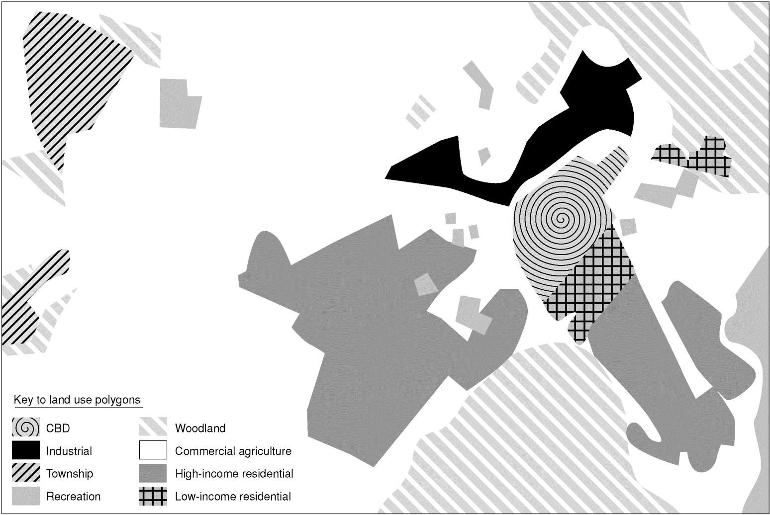
GIS Map for answer to 19.1 Land use zones
Major transport routes in Nelspruit and the surrounding Mbombela Metropolitan Municipality
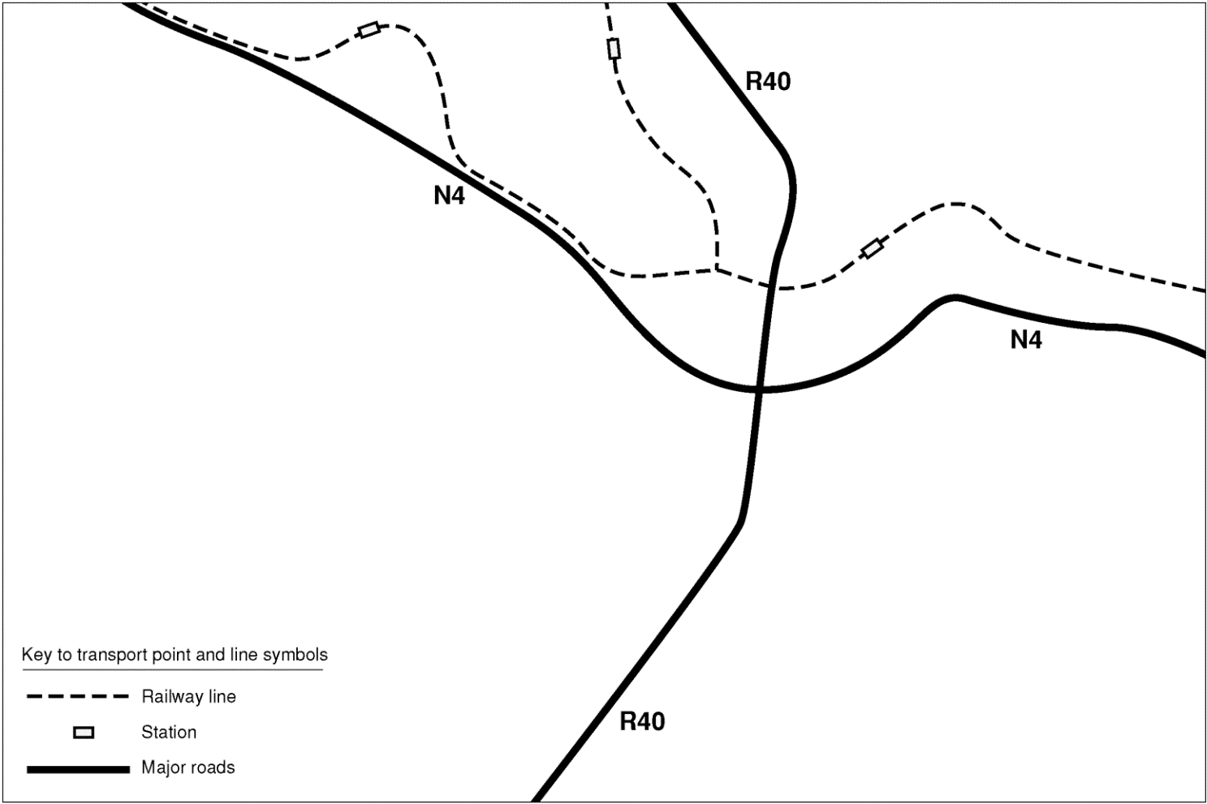
GIS Map for answer to 19.3 Major transport routes

