PRACTICE EXAM PAPER 2 MARKS: 300

BUSINESS STUDIES GRADE 11 TIME: 3 hours

DATE: November

SECTION A (COMPULSORY)

QUESTION 1

**1.1** Four options are provided as possible answers to the following questions. Choose the answer and write only the letter (A–D) next to the question number (1.1.1–1.1.10).

**1.1.1** _____ is used to finance the day-to-day running of a business.

A Owner’s equity

B Working capital

C Fixed capital

D Operational capital

**1.1.2** The process of discussing or bargaining used by an employer and a trade union representative to reach an agreement is also known as:

A negotiation.

B employment equity.

C compromise.

D collective action.

**1.1.3** A _____ is a document issued by a business inviting the public to purchase shares.

A Notice of Incorporation

B business charter

C Memorandum of Incorporation

D prospectus

**1.1.4** _____ is the efficiency of production.

A Supply and demand

B Productivity

C Routing

D Scheduling

**1.1.5** A private company has _____ shareholders.

A 1 to 50

B anything over 7

C a minimum of 1and no limit to the number of

D 1 to 20

**1.1.6** An example of an intermediary is:

A Pick n Pay

B Makro Wholesalers

C Joe’s Cafe

D Edgars

**1.1.7** _____ is a way to finance debtors by selling outstanding debts to a third party.

A A bank overdraft

B A short-term loan

C Working capital

D Factoring

**1.1.8** This type of distribution is used when the manufacturer needs to demonstrate the goods for sale.

A Direct marketing

B Indirect marketing

C Advertising

D Target marketing

**1.1.9** The profits in this type of business are distributed according the business done with the members.

A Close Corporation

B NGO

C Co-operative

D CBO

**1.1.10** Fishing quotas have left many without jobs. This situation requires problem solving in the _____ environment.

A primary

B macro

C micro

D market (10 × 2) [20]

**1.2** Choose the correct word(s) from those given in brackets. Write only the question number and word(s).

**1.2.1** Media Mogul Industries invests R2 million in a new library. This is a form of (corporate social investment / advertising / promotion).

**1.2.2** A (graph / flow chart / pie chart) shows the specific steps that can be used in a presentation.

**1.2.3** An appointment within a business is known as (internal / external) recruitment.

**1.2.4** The polish for shoes in a shoe factory is a (fixed / variable) cost.

**1.2.5** (Leasing / Hire purchase) is when a business pays for the use of something. (5 × 2) [10]

**1.3** Choose a description from Column B that matches a term in Column A. Write only the letter next to the question number.

|  |  |
| --- | --- |
| Column A | Column B |
| 1.3.1 Jobbing | A The function that satisfies a need in exchange for money |
| 1.3.2 Capacity | B The amount of money used to purchase land, buildings and equipment |
| 1.3.3 Marketing | C The maximum possible output of a factory |
| 1.3.4 Fixed capital | D Production where each product has its own characteristics |
| 1.3.5 Stakeholders | E The people who have an effect on the activities in a business and how it   is managed |

(5 × 2) [10]

**TOTAL SECTION A: 40**

SECTION B (Answer any THREE questions)



QUESTION 2

This large sign is placed at the entrance to the factory. The Health and Safety Officer at the factory changes the number of days when the morning shift begins. The factory mass-produces packaging for the wholesale and retail industry. Its 1 000 employees work shifts and use various machines. Strict stock control and quality controls are employed to ensure the cost price remains as low as possible.

**2.1** Briefly explain FOUR disadvantages of mass production. (8)

**2.2** A manufacturing business can be defined as a business in which inputs are transformed into outputs. Explain this statement with the use of an example. (9)

**2.3** Why do you think this sign is placed at the entrance to the factory? (4)

**2.4** Identify and briefly explain FOUR rights that employees have regarding workplace health and safety. (12)

**2.5** Identify FIVE things a worker can do to ensure their safety when working with machines and equipment. (10)

**2.6** Identify the legislation that addresses health and safety issues in the workplace. (1)

**2.7** Describe the purpose of calculating a break-even point. Explain how it can assist the factory manager. (6)

**2.8** Explain the importance of routing in this factory. (6)

**2.9** Explain the difference between competition and demand-orientated pricing policies. (4) [60]

QUESTION 3

|  |
| --- |
| **Transport minister temporarily slams brakes on Gauteng’s tolls.**  (*Saturday Independent*: 14 Jan 2012 – Noni Mokati)  Faced with an unprecedented civil resistance threat to planned Gauteng electronic toll road system, Transport Minister Sbu Ndebele yesterday ordered a temporary halt to the plan. A government spokesperson said this is a clear indication that the government listens to the people and considers their views. A civil rights group, AgriForum, is continuing their planned legal action against the new toll roads and this could place added pressure on the government to abandon its plans to charge toll fees. Cosatu said that if, after consultation processes, similar proposals for these specific toll roads are brought back to the table, they would continue their planned mass action. |

**3.1** Explain which environment this situation refers to and how it affects a business. (6)

**3.2** Describe how a business can adapt to challenges from this environment. (6)

**3.3** Explain what a civil rights group is and discuss how it can contribute to the socio-economic situation of a community. (6)

**3.4** Explain mass action as described in this extract. (8)

**3.5** The electronic toll road system will add hundreds of rand to business costs. Mass action will also hurt business. Explain this statement. (8)

**3.6** The electronic toll system was outsourced to an overseas company. Explain FIVE advantages of outsourcing as a means to acquire a business. (10)

**3.7** Discuss how mass action can influence the government’s decisions on this toll system. (6)

**3.8** Explain the difference between good and bad decisions in this scenario. (4)

**3.9** Give THREE ways AgriForum and Cosatu could work together to achieve their aim which is to stop the electronic toll system. (6) [60]

QUESTION 4

Suzie is working as a receptionist and has just completed her Marketing Diploma. The business she works for has a vacancy in the Marketing Department. She is not sure whether she wants to apply for the position as there is a lot of conflict within the Marketing Department. She has enough stress coping with the busy phone system and the problems in her private life.

**4.1** Explain the importance of an employment contract and list SIX items that must be included. (10)

**4.2** Briefly discuss the recruitment process that the Human Resources Department must follow to find a suitable person for the marketing position. (10)

**4.3** Compare the basic purposes of the Labour Relations Act and the Basic Conditions of Employment Act. (12)

**4.4** Explain the following terms:

**4.4.1** Pension (6)

**4.4.2** Medical aid (6)

**4.4.3** PAYE (6)

**4.5** Explain the consultation process for managing the conflict in the Marketing Department. (10) [60]

QUESTION 5

Amanzi Beadwork CC has sold necklaces which were used in an international fashion show. The owners feel that expanding into foreign markets should be very easy.

**5.1** Identify two external factors in the micro-environment that could affect business success. (8)

**5.2** Explain to Amanzi’s owners how the cost of transport will affect their sales overseas. (8)

**5.3** Amanzi Beadwork is in the growth phase of their product life cycle. Discuss the next two stages it will encounter and how this will affect its marketing strategy. (2 × 6)

**5.4** Compare direct and indirect marketing. (8)

**5.5** Discuss FIVE advantages of exporting beadwork overseas. (10)

**5.6** Tabulate the differences between jobbing and batch production methods for the beadwork business. (12) [60]

QUESTION 6

Amanzi Beadwork CC will need to obtain additional capital to start its foreign marketing expansion.

**6.1** Tabulate the differences between a close corporation and a private company. (16)

**6.2** Discuss three factors that will affect its business relationships with foreign retailers. (3 × 4)

**6.3** Compare the differences between equity and long-term capital as a form of funding this expansion. (10)

**6.4** Give six tips to the owners of Amanzi Beadwork that will help them write effective business   
e-mails. (12)

**6.5** Discuss the role Amanzi Beadwork could play in its community. (10) [60]

**TOTAL SECTION B: 180**

SECTION C (Answer any TWO questions)

QUESTION 7

|  |
| --- |
| The concept of a recognition agreement goes back to 1970, when most trade unions currently affiliated to Cosatu were founded. The unions did not enjoy the legal support for collective bargaining that they do now. They sought to reach agreements with employers in whose businesses they recruited members. These employees would ‘recognise’ a union for various purposes. The Labour Relations Act has changed this situation. |

Write an article for a newspaper explaining the nature and purpose of the Labour Relations Act, the role of trade unions and a brief history of trade unions in South Africa. [40]

QUESTION 8

Beauty Care is a new cosmetics business situated in Gauteng. Explain the FOUR Ps of marketing as they relate to this business. [40]

QUESTION 9

|  |
| --- |
| Entrepreneurship is a dynamic process of vision, change and creation. Entrepreneurs are jack-of-all-trades but they are only as good as their weakest skill. |

Describe the qualities of an entrepreneur. Also explain how to form a public company. [40]

QUESTION 10

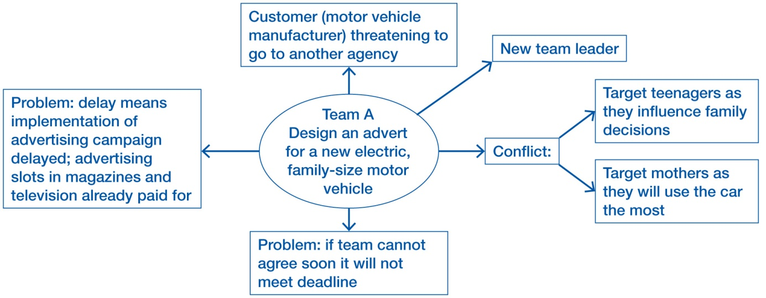

Write a report to assist the Marketing Manager in explaining the following:

* Stages of team building
* Belbin role theory
* Conflict management skills to resolve this conflict. [40]

**TOTAL SECTION C: 80**

**GRAND TOTAL: 300**