ADDITIONAL EXEMPLAR SEPTEMBER
EXAMINATION PAPER 2
(TOPICS 4, 5 and 6)

TIME: 3 hours

MARKS: 150

Instructions:
1 This question paper consists of SIX questions.
Questions 1 and 4: Civil resistance in SA
Questions 2 and 5: Coming of Democracy to SA
Questions 3 and 6: A New World Order
2 Each question contains 50 marks.
3 Candidates are required to answer THREE questions. ONE (1) source-based question, ONE (1) essay question and ONE (1) other, either an essay or a source-based question.
4 Candidates may answer two questions on the same topic.
5 When candidates answer questions, they are required to demonstrate application of knowledge, skills and insight.
6 Rewriting of the sources as answers will be to the disadvantage of candidates.
7 Write neatly and legibly.

SECTION A: SOURCE-BASED QUESTIONS
Choose ONE question from Section A. Refer to the sources in the Addendum to answer the questions in Section A.

QUESTION 1: CIVIL RESISTANCE IN SOUTH AFRICA 1970s TO 1980s
[Focus: The challenge of Black Consciousness to the Apartheid State]
Study Source 1A and answer the following questions:
1.1 What do the abbreviations ANC and PAC stand for? (2×1) (2)
1.2 According to Source 1A, how did Black Consciousness start? (1×2) (2)
1.3 According to Source 1A, give a short background summary on Steve Biko. (2×2) (4)
1.4 Use your background knowledge and Source 1A to explain what SASO was. (3×1) (3)
1.5 Study the symbol of the Black Consciousness Movement in Source 1A. In your opinion is there any connection between the symbol and the salute the Black Power movement in America used? (3×1) (3)

Study Source 1B and answer the following questions:
1.6 According to Source 1B, as well as your understanding and knowledge of the context, what were the reasons for the rise of Black Consciousness? (2×2) (4)
1.7 Use Source 1A and Source 1B to write a summary (one paragraph) of your understanding of the nature/characteristics of Black Consciousness. (6)
1.8 Identify what type of source Source 1B is and explain the usefulness of such a source to history students. (3×1) (3)

1.9 According to Source 1B: ‘Soon BC became the rallying cry of an entire nation.’ Explain in your own words what you think this phrase means. (3×1) (3)

Study Source 1C and answer the following questions:
1.10 Give three things shown in the source that tell you it was created in the 21st century. (3×1) (3)
1.11 What happened 30 years ago? Quote from the source to substantiate your answer. (2×1) (2)
1.12 What message is the cartoonist trying to put across? Use information from the cartoon to support your answer. (4×1) (4)
1.13 According to Source 1C, can cartoons be seen as reliable historical evidence? Explain your answer in full. (3×1) (3)
1.14 According to Source 1C, who is the cartoonist? (1×1) (1)

Study Source 1D and answer the following questions:
1.15 According to Source 1D, what reason did Justice Minister, Jimmy Kruger, give for the death of Steve Biko? Provide details from the source to support your answer. (3×1) (3)
1.16 What was the message that Jimmy Kruger was trying to get across with this statement? (2×1) (2)
1.17 How do you know that this source is an extract from a newspaper? (2×1) (2)
1.18 According to Source 1D, what rank did office did Jimmy Kruger hold? (1×1) (1)
1.19 Can newspaper reports generally be seen as reliable sources of information? Provide one reason for your answer. (2×1) (2)
[50]

QUESTION 2
[FOCUS: THE COMING OF DEMOCRACY TO SA]

The Truth and Reconciliation Commission
Study Source 2A and answer the following questions:
2.1 According to Source 2A, what does a Truth Commission in theory necessitate? Explain in your own words. (2×2) (4)
2.2 According to Source 2A, what other factors are involved in the reconstruction process? Quote words from the source to support your answer. (2×1) (2)
2.3 With your background knowledge and in reference to Source 2A, what possible role can a Truth Commission then play? Explain in your own words. (5×1) (5)
2.4 According to Source 2A, would you say that the content of this source is useful? Explain your answer. (3×1) (3)
2.5 Name the two authors of the article. (2×1) (2)

Study Source 2B and 2C then answer the following questions:
2.6 Identify the cartoonist of Source 2B. (1×1) (1)
2.7 According to source 2B, what does the term ‘inquest’ in this context mean? Explain in short in your own words. (2×1) (2)
2.8 Study source 2B carefully. How did the individual’s answer change from 1977 to 1997 in terms of how Biko died? Use details from the cartoon to support your answer. (2×2) (4)
2.9 By comparing Source 2B with Source 2C, explain in your own words the message the two different sources are trying to bring across to you as the reader. Are the message from the two sources thus essentially the same or not. To validate your answer you must use detail from the cartoons in both sources. (3×2) (6)

2.10 Which of the two sources are more reliable in portraying the true purpose of the TRC – if at all? Explain your answer by referring to both sources if necessary, as well as explaining in your own words what you think the overall messages of the two cartoons in Sources 2B and 2C are.
(Your answers will be assessed using the table on page 67 of the Learner’s Book.) (8)

2.11 According to Source 2C as well as your understanding and knowledge of the context, what does the box Amnesty soap powder represent? Explain your answer. (2×1) (2)
2.12 How did the TRC Amnesty change Brian Mitchell’s life? (2×1) (2)

Study Source 2D and then answer the following questions:
2.13 Identify the author of Source 2D. (1×1) (1)
2.14 What kind of source is Source 2D? b (1×1) (1)
2.15 What, according to Source 2D, are the reasons for the High Court’s decision that there has to be re-run of the amnesty process? Quote words from the source to support your answer. (2×2) (4)
2.16 After carefully reading through Source 2D, determine whether the content of this source is biased? Based on this assessment, would you consider this source to be a reliable source? (3×1) (3)
2.17 According to Source 2D, what does the abbreviation NPA stand for? (1×1) (1)
[50]

Question 3: A new world order
[Focus: Challenges of poverty]
Study Source 3A and answer the following questions:
3.1 According to the caption in Source 3A, what happened after the Group Areas Act was removed? Quote words from the source to support your answer. (2×1) (2)
3.2 In reference to Source 3A, what was the result of this move referred to in question 3.1? (2×2) (4)
3.3 Study Source 3A carefully. Would you consider the photograph to be a reliable source of evidence? Explain your answer. (3×1) (3)

Study Source 3B and answer the following questions:
3.4 What, according to Source 3B, was one of the most important challenges South Africa faced in 2006? Quote words from the source to support your answer. (2×1) (2)
3.5 In reference to Source 3B, how is it obvious that approximately18 million South Africans didn’t enjoy the benefits of their new freedom by 2006? Use details from the source to support your answer. (2×2) (4)
3.6 What suggestion did the author of Source 3B make that would help solve the poverty problem in South Africa? Quote from the source to support your answer. (2×1) (2)
3.7 Source 3B is an extract from a Grade 8 Social Sciences textbook from 2006. Can this source therefore then be deemed to a reliable source of evidence? Explain your answer in full. (4×1) (4)

Study Source 3C and answer the following questions:
3.8 What does the abbreviation RDP stand for? (1×1) (1)
3.9 Use Source 3C and your understanding of the historical context to explain how South Africa developed into one of the most unequal societies in the world? (3×1) (3)
3.10 After carefully reading Source 3C, identify the initial steps taken by the new South African government to try and deal with the poverty problem in South Africa. (3×1) (3)
3.11 According to Source 3C, how successful were the measures taken by the RDP in order to relieve poverty? Use details from the graph to support your answer. (3×1) (3)

Study Source 3D and answer the following questions:
3.12 Use the information in Source 3D and your own understanding of the situation to explain the rising problem of poverty and unemployment worldwide. (2×3) (6)
3.13 According to Source 3C, most people in the developing countries are actually very poor. Provide a quote from Source 3D to validate this statement. (1×2) (2)
3.14 How do we know that even developed countries are struggling with a problem of poverty? Quote words from the source to support your answer. (2×1) (2)

Study Source 3E and answer the following questions:
3.15 Compare Source 3D with Source 3E. Which one of the two sources would you deem to be more reliable than the other? In your explanation you must also refer to the source/s in order to validate your answer. (3×1) (3)
3.16 What, according to Source 3E, is the result of the daily struggle in the poorer countries of the world? Quote words from the source to support your answer. (2×2) (4)
3.17 Can Source 3E be considered to be a valuable source of information? Provide one reason for your answer. (2×1) (2)
[50]

SECTION B: ESSAY QUESTIONS
QUESTION 4: THE CRISIS OF APARTHEID IN THE 1980s
Outline the international responses to apartheid in the 19880s which played a role in bringing it to an end in 1994. [50]

QUESTION 5: HOW DID SOUTH AFRICA EMERGE AS A DEMOCRACY?
Explain why many South Africans, due to the internal upheaval, experienced the final road to democracy with anxiety.
[50]

QUESTION 6: THE END OF THE COLD WAR − THE EVENTS OF 1989
To what extent were Gorbachev’s reforms responsible for the disintegration of the Soviet Union? [50]

ADDITIONAL EXEMPLAR SEPTEMBER
EXAMINATION PAPER 2
ADDENDUM
SOURCES FOR QUESTION 1: CIVIL RESISTANCE IN SOUTH AFRICA 1970s TO 1980s
[Focus: The challenge of Black Consciousness to the Apartheid State]

SOURCE 1A A description of how Black Consciousness started. From Apartheid Museum, Understanding Apartheid, Oxford University Press, Cape Town, 2006

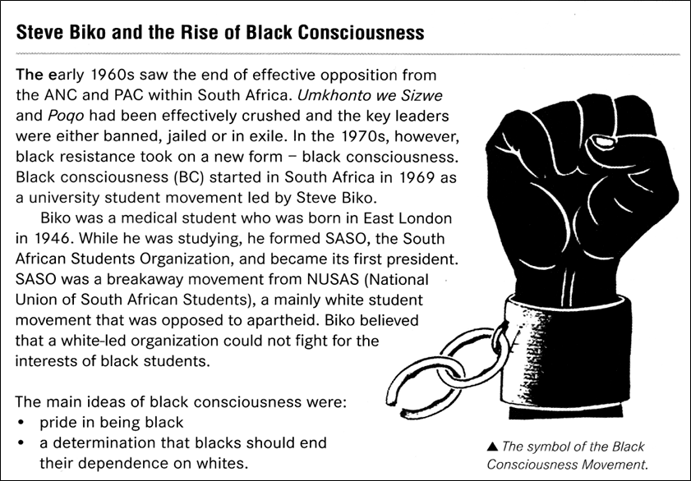

SOURCE 1B An explanation of why Black Consciousness thinking spread. From http://www.sahistory.org.za/articles/down-afrikaans

Rise of Black Consciousness
Aware that they were the moral and intellectual equals of white students, but that they were the pawns in the racial and economic policies of the white government, African students began uniting under a new and highly significant banner: Black Consciousness.
Black Consciousness was, and perhaps still is, a new way of looking at the world. Liberation, its proponents argued, would come about only when Africans threw off their shackles of fear and their feelings of inferiority, and conducted their own political campaigns instead of relying on white liberals to map out their strategies. Whites, they argued, were too enmeshed in the apartheid system ever to be reliable allies.
Black Consciousness engendered a new sense of pride in millions of Africans: blackness became something to be proud of, to be defiant about and worth fighting for. And so the message was spread − by students in the rural-based tribal colleges to younger brothers and sisters in the townships. Soon Black Consciousness became the rallying cry of an entire generation.

SOURCE 1C This cartoon shows former Prime Minister Vorster and former Minister of Justice, Jimmy Kruger, in hell. ‘Black Wednesday’ refers to 19 October 1977 when the banned Black Consciousness organisations. From http://www.zapiro.com/cartoon/542056-071019mg

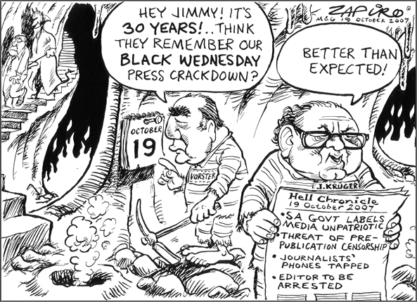

SOURCE 1D The extract below is the government explanation of what happened to Steve Biko, reported in the Cape Times, 14 September 1977. From Chris Culpin, South Africa Since 1948, John Murray (2000), London,
page 86
‘The political leader Mr Stephen Biko died while in security police custody, eight days after he began a hunger strike,’ the Minister of Justice, Mr Jimmy Kruger, said yesterday.
Mr Kruger detailed how Mr Biko, 30, refused meals and water from September 5th, and how he was examined by various doctors, then sent to a prison hospital in Port Elizabeth, taken back to police cells and finally transferred to Pretoria where he died on the night of his arrival.

SOURCES FOR QUESTION 2:
[Focus: The coming of democracy to SA – The TRC]

SOURCE 2A The following is an extract of an article published on the Centre For The Study of Violence and Reconciliation’s Web-site. Brandon Hamber & Steve Kibble, http://www.csvr.org.za/wits/papers/papbhsk.htm

What role is there for a truth commission?
Establishing a truth commission can be, in theory, part of a broad process of reconstruction and transformation, moving a country towards peace, reconciliation, and the initiation of a human rights culture. It is only one part of that process: other institutional changes are necessary (such as reform of political and military bodies), as well as government action in promoting peace, reconciliation and justice.
So what might be the role of a truth commission? They can promote debate on the past and future of a country. They can help bring human rights abuses to an end and set in motion the creation of a culture of respect and protection of human rights. Truth commissions can provide some comfort for survivors, and can be linked to establishing effective reparations. They can also help produce a balanced historical record.
In reality, however, commissions have rarely had all the positive impacts that proponents claim. Most have been unable to deal effectively with the full consequences of extensive political violence. In most countries where truth commissions have been established, the number of unsolved cases of human rights violations matches the new facts uncovered. In many instances, truth commissions have issued recommendations for reform that have never been implemented.

SOURCE 2B A cartoon criticising the TRC by suggesting the full truth was not being told. From the Sowetan 15 September 1997

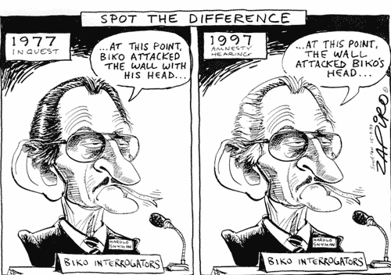

SOURCE 2C A cartoon commenting on the granting of amnesty to Brian Mitchell on 10 December 1996. From Mail & Guardian, 12 Dec 1996. Former policeman Brian Mitchell was granted amnesty and released from Pietermaritzburg prison after serving less than five years of a 30-year sentence for his role in killing 11 people in the 1988 Trust Feed massacre.

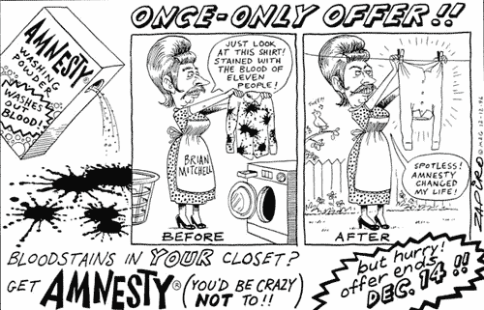

SOURCE 2D The following is an extract from a report issued by the George Mason University – Global Studies Review. From http://www.globality-gmu.net/archives/1831
Reversing Accountability in South Africa: From Amnesty to Pardons and Non-Prosecutions
In March 2003 the National Prosecuting Authority (NPA) established a Priority Crimes Litigation Unit which was to oversee its processing of TRC related cases alongside the prosecution of other high level crimes such crimes under the Rome Statute and terrorism.
While survivors and their families were to be given an opportunity to comment on cases, they would not have an opportunity to challenge the perpetrator’s version of events. Furthermore the information gathered by the perpetrator would not be released to the public and there would be no judicial review of such decisions on immunity. Survivors and human rights organisations challenged the policy in the High Court, and in December 2008, the court ruled that the policy amounted to a rerun of the amnesty process and infringed on survivors’ rights, was therefore unconstitutional. The case is presently on appeal.

SOURCES FOR QUESTION 3: A new world order
[Focus: The end of the Cold War and a new global world order]

SOURCE 3A After the Group Areas Act was removed people were allowed to live where they wanted to (or could afford to). Squatter areas grew bigger as people moved to the towns to look for work. From J. Bottaro et al, In Search of History Secondary Book 1, Oxford University Press, Cape Town, page 171 (Photo SAL – Chris Schoeman)
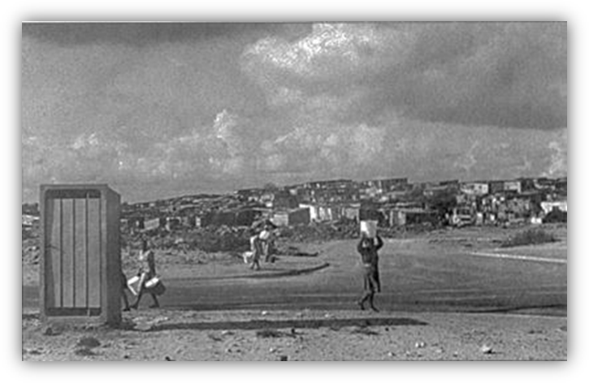

SOURCE 3B From Shuter Social Sciences Grade 8, Shuter and Shooter, Pietermaritzburg, 2006, page 185

One of the most important challenges currently facing South Africa is the overcoming of widespread poverty.. It is estimated that approximately 40% of South Africans are living in poverty, with the poorest 15% engaged in a desperate struggle to survive. This means that approximately 18 million out of 45 million people have not enjoyed the benefits of our new freedom. All South Africans need to work together towards raising the . All South Africans need to work together towards raising the standard living for our poorer fellow citizens.

SOURCE 3C From Heinemann Outcomes History, Heinemann, Johannesburg, page 34

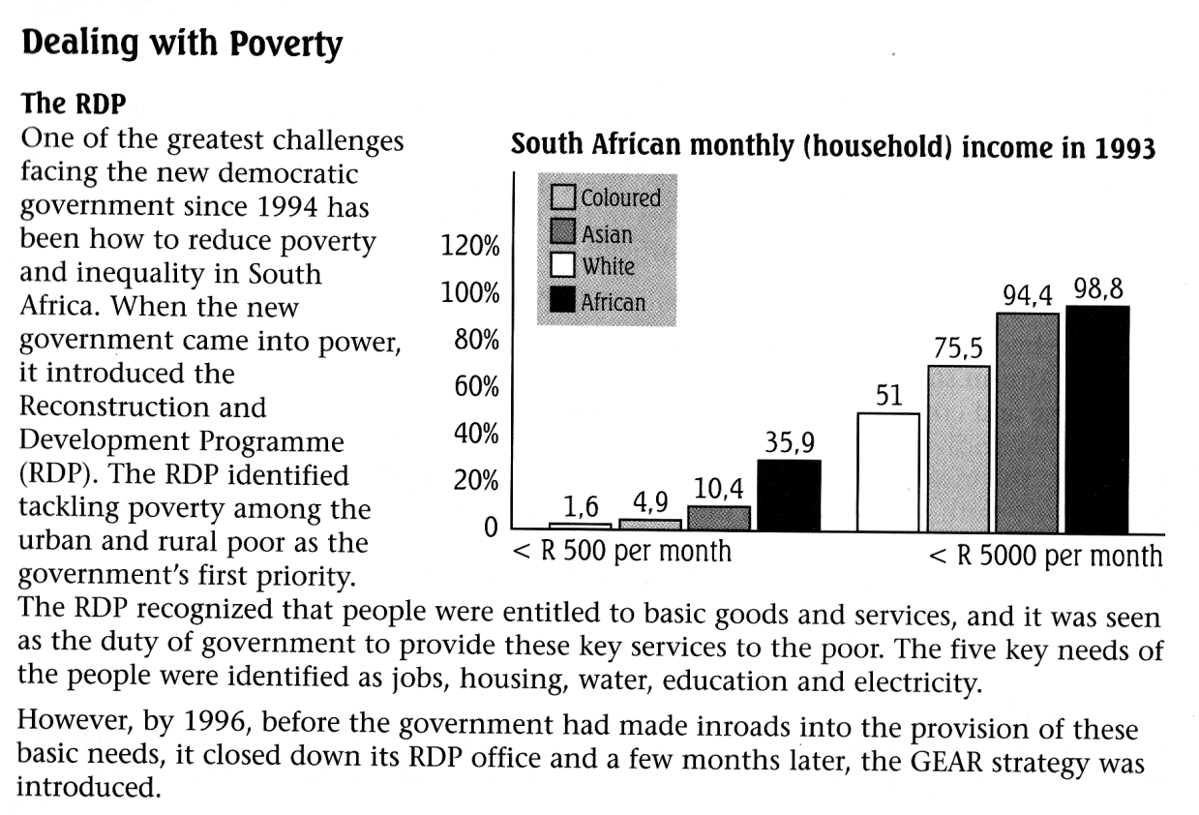

SOURCE 3D From N. Kelly and M. Whittock, Heinemann History Study Units: The Twentieth Century World, page 93

Continuing poverty
Yet it would be wrong to think that these advances have made everyone more knowledgeable and brought about a better standard of living for all. In many of the world’s developing countries people live on the edge of starvation and appear to have benefited little from technological advances elsewhere. Even within the developed countries of the world there is great variety in the standards of living. Whilst many people have high standards of living, increasing numbers are having to deal with problems caused by unemployment and poverty.

SOURCE 3E Extract from the ‘Brandt Report’ written in 1980. Brandt was the ex-leader of West Germany who was commissioned to carry out an investigation by members of developed and undeveloped countries. From From N. Kelly and M. Whittock, Heinemann History Study Units: The Twentieth Century World, 2006, page 185

Many hundreds of people in the poorer countries are preoccupied solely with survival and elementary needs. For them work is frequently not available, or when it is, pay is very low and conditions often intolerable. Homes are constructed of impermanent materials and have neither piped water nor sanitation. In the developed countries ordinary men and women face genuine economic problems – uncertainty, inflation, the fear of, not the reality of, unemployment. But they rarely face anything resembling the total deprivation of the under-developed countries.

