ADDITIONAL EXEMPLAR SEPTEMBER
EXAMINATION PAPER 1
(TOPICS 1, 2 and 3)

TIME: 3 hours

MARKS: 150

Instructions:
1 This question paper consists of SIX questions.
Questions 1 and 4: The Cold War
Questions 2 and 5: Independent Africa
Questions 3 and 6: Civil Society Protest
2 Each question contains 50 marks.
3 Candidates are required to answer THREE questions. ONE (1) source-based question, ONE (1) essay question and ONE (1) other, either an essay or a source-based question.
4 Candidates may answer two questions on the same topic.
5 When candidates answer questions, they are required to demonstrate application of knowledge, skills and insight.
6 Rewriting of the sources as answers will be to the disadvantage of candidates.
7 Write neatly and legibly.

SECTION A: SOURCE-BASED QUESTIONS
Choose ONE question from Section A. Refer to the sources in the Addendum to answer the questions in
Section A.
QUESTION 1: THE COLD WAR
[Focus: USSR and USA and the creation of spheres of interest]
Key question: What were the main areas of competition in Europe between the superpowers?

Study Source 1A and answer the following questions:
1.1 Identify the figure portrayed as the hen, as well as the country he represented. (2×1) (2)
1.2 Identify the figure portrayed in the foreground of the cartoon, as well as the country he represented. (2×1) (2)
1.3 Use Source 1A and your own knowledge to explain why Marshall Tito is portrayed as a duckling when the other Communist States are portrayed as little chickens? (2×3) (6)
1.4 The little chicks portrayed in the cartoon represents the other communist satellite states. Use your understanding of the context to explain the term ‘satellite state’. (4×1) (4)

Study Source 1B and answer the following questions:
1.5 Do you think that Source 1B is a reliable historical source? Explain your answer in full. (3×1) (3)
1.6 Use your understanding of the context to explain what the Berlin Blockade and Berlin Airlift were. (2×3) (6)
1.7 Use the information in Source 1B as well as your understanding of the context to explain in your own words why the Berlin Airlift was so important. (3×2) (6)

Study Source 1C and answer the following questions:

1.8 Source 1C indicates a divided Europe – 1945-1989. What was the treaty called that would later lead to the formation of NATO in 1949? (1×1) (1)
1.9 What was the Warsaw Pact? (3×1) (3)
1.10 Use Source 1C and your own knowledge to explain the reasons for the formation of NATO, as well as its main aim. (4×1) (4)
1.11 Explain with reference to Source 1C, why you would consider this to be a valuable source of evidence in the study of the history of this time period. (4×1) (4)

Study Source 1D and answer the following questions:
1.12 According to Source 1D, identify the fears the author had. Quote words from the source to support your answer. (2×1) (2)
1.13 Use your own knowledge to explain why it was so important to the USA to hold on to Berlin. (4×1) (4)
1.14 Would you consider Source ID to be a reliable historical source of evidence? Briefly explain your answer. (2×1) (2)
1.15 Explain why Source 1D is a primary source. (1×1) (1)
[50]

QUESTION 2: AFRICA AND THE COLD WAR
[Focus: Angola − Outbreak of civil war 1974]
Key question: What were the causes of the Angolan Civil War?

Study Source 2A and answer the following questions:
2.1 What, according to Source 2A, was the Angolan Civil War? (1×1) (1)
2.2 Use Source 2A, as well as your understanding of the context, explain in your own words what a coup d’état is?
(3×1) (3)
2.3 According to Source 2A, what was the direct result of the coup in Portugal on the situation in Angola in 1974? Quote words from the source to support your answer. (3×1) (3)
2.4 ‘... the agreement mandated a new national government and army, along with Angola’s first multi-party elections.’ Explain in your own words what this quotation from the source is actually saying. (2×2) (4)
2.5 According to Source 2A, what was Savimbi’s attitude, and consequent reaction to the election in Angola? Quote from the source to support your answer. (2×1) (2)
2.6 How do you know that Jose dos Santos supported communist policies? Quote from the source to support your answer. (2×1) (2)

Study Source 2B and answer the following questions:
2.7 What message is the cartoonist putting across about South Africa invading Angola? Use details from the cartoon to support your answer. (4×1) (4)
2.8 Do you think the cartoonist is critical of, or sympathetic towards, the South African view-point? Refer to the cartoon in your answer. (5×1) (5)
2.9 Study the caption to the source as well as the source in depth. There seem to be a contradiction in terms of the dates. Why do you think this is the case and what does this tell you about the government’s action and its relationship to this newspaper? (2×2) (4)
2.10 Who, according to Source 2B, was the cartoonist? (1×1) (1)

Study Source 2C and answer the following questions:
2.11 According to Source 2C, how do you know that there was a third contending group involved in the armed struggle in Angola? Quote words from the source and caption to support your answer. (2×1) (2)

2.12 What does the acronym UNITA stand for? (1×1) (1)
2.13 Study the map carefully. The information provided in the caption explains that UNITA was relying on support from South Africa in the south. South Africa, however, does not share a border with Angola. Explain how would have been possible for UNITA to rely on tactical support from South Africa if South Africa was not an immediate geographical neighbour to Angola. (4×1) (4)

Study Source 2D and answer the following questions:
2.14 Compare Source 2A with Source 2D. There is a contradiction of information. Identify the contradiction by quoting from each source. (2×1) (2)
2.15 Very briefly explain why internet sources can be unreliable as historical sources. (1×1) (1)
2.16 Using information in Source 2D as well as your understanding of the historical context, explain what the author of Source 2D meant by:
‘The war was one of the most prominent Cold War proxy wars...’ (5×1) (5)
2.17 According to Source 2D, how many civilians died in the conflict in Angola? Quote words from the source to support your answer. (2×1) (2)
2.18 Provide information from Source 2D that indicates that Angola had two opposing political groups that technically ruled the country after 1975. (4×1) (4)
[50]

QUESTION 3: CIVIL SOCIETY PROTEST
[Focus: Role, impact and influence of Martin Luther King Jr.]
Study Source 3A and answer the following questions:
3.1 In this cartoon there is an indirect reference to incidents and one specific individual involved in the Civil Rights Movement in the late 1950s and 1960s. Who is this individual, and how do we know this? Use information from the cartoon to verify your answer. (4×1) (4)
3.2 Provide at least two examples from the source that is proof to you as a history student that this is a contemporary cartoon. (2×2) (4)
3.3 With reference to the source as well as your understanding of the historical context, what do you think is the cartoonist’s message in relation to the legacy of Martin Luther King Jr on today’s society? (3×1) (3)
3.4 Do you think the cartoonist is in any way critical in his/her message? Refer to the cartoon in your answer. Use details from the cartoon to support your answer. (3×1) (3)

Study Source 3B and answer the following questions:
3.5 Use the source as well as your understanding of the historical context to explain who went to the Southern states of the USA on bus rides as an act of defiance against unequal racial treatment. (2×1) (2)
3.6 According to the visuals in Source 3B, what weapons did the police use? (1×1) (1)
3.7 In stark contrast to the methods used by the police in Source 3B, Martin Luther King Jr was a supporter of non-violence. In reference to your historical understanding and knowledge of the historical context to this situation, explain how Martin Luther King Jr had hoped to, and did use, these methods to achieve his aims. (8×1) (8)
3.8 With your understanding and knowledge of the historical context, explain in your own words why police in the Southern states of the USA, as seen in Source 3B, opposed civil rights actions such as the Freedom Rides. (4×1) (4)

3.9 According to Source 3B, what was the outcome of the violent attacks on the Freedom Riders? Quote words from the source to support your answer. (2×1) (2)
3.10 In reference to Source 3B, would you consider this photograph to be a reliable historical source of evidence? Explain your answer. (4×1) (4)

Study Source 3C and answer the following questions:
3.11 Compare Source 3A with Source 3C. The content of the words spoken by the little black boy in the cartoon is a loose paraphrase from Martin Luther King’s ‘I have a dream’ speech. In reference to Source 3C, quote the correct content of the last part of King’s speech. (2×1) (2)
3.12 Source 3C: ‘I have a dream that one day on the red hills of Georgia sons of former slaves and the sons of former slave owners will be able to sit down together ...’ Taking this quotation from Source 3C into consideration, what do you think did Martin Luther King Jr meant by this part of his speech? Explain in full. (6×1) (6)
3.13 In reference to the photograph in Source 3C, identify at least three grievances to be seen on the posters of the marchers. (3×1) (3)

Study Source 3D and answer the following questions:
3.14 Who do you think is the President who is asking these questions in his speech? (1×1) (1)
3.15 With your understanding and knowledge of the historical context, identify and explain the battle this President refers to in his first question in Source 3D? (3×1) (3)
[50]

SECTION B: ESSAY QUESTIONS
Choose ONE question from Section B. Your essay should be 900−1 000 words.

QUESTION 4: The Cold War
[Focus: China as a Case Study]
‘In time of difficulties, we must not lose sight of our achievements.’
Mao Zedong

With reference to the above quotation, explain how Mao Zedong helped to establish China as a superpower by the time of his death. [50]

QUESTION 5: Independent Africa
[Focus: Successes and challenges faced by the leaders]
What were the political challenges, both internal and external, that Tanzania and Congo faced after independence? How successful were they in resolving them? You should concentrate on the following:
- Types of government
- Political stability and instability
[50]

QUESTION 6: Civil Society Protest
[Focus: The Civil Rights Movement in the USA]
What forms of civil protest were used in the US Civil Rights Movement and what gains did it make as a result?
[50]

ADDITIONAL EXEMPLAR SEPTEMBER
EXAMINATION PAPER 1
ADDENDUM
SOURCES FOR QUESTION 1
[Focus: USSR and USA and the creation of spheres of interest]
SOURCE 1A A cartoon commenting on disunity amongst the communist countries of Easter Europe. From International Relations – The Turret Senior History Course, Turret Correspondence College, 1987 page 48

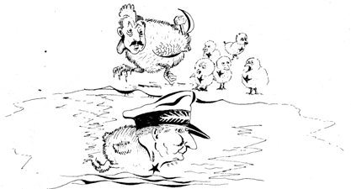

SOURCE 1B This photograph depicts a time during the Berlin Blockade – an American Aeroplane brings supplies. Greatstock/Corbis

SOURCE 1C Map of a divided Europe – Cold War Alliances 1945–1989 (from the Learner’s Book for this series)

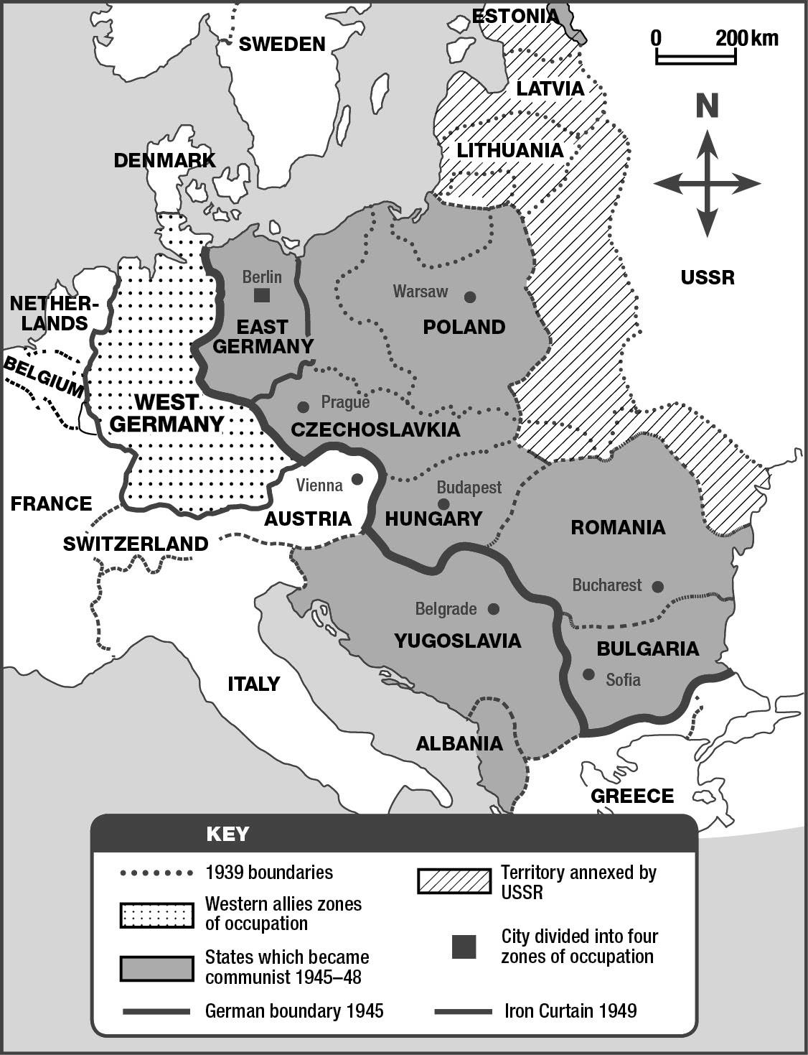

SOURCE 1D The following is an account written by a secretary living in Berlin at the time of the Berlin Airlift.

Then the day came when the airlift started. Father didn’t believe it. He rode to Tempelhof airport on his bicycle. He was away a long time. When he came home, he said ‘They’re actually doing it. They’re flying food into Berlin. But they won’t be able to bring in enough. Think of this huge city with its millions of people.’

SOURCES FOR QUESTION 2: AFRICA AND THE COLD WAR
[Focus: Angola − Outbreak of civil war 1974]

SOURCE 2A The following source is an extract from an article on an internet website, Black Past. Org http://www.blackpast.org/?q = gah/angolan-civil-war-1975-2002 (An online reference guide to African American History)

Angolan Civil War (1975-2002)
The Angolan Civil War, beginning at the time of the country’s independence from Portugal in 1975, was a 27-year struggle involving the deaths of over 500,000 soldiers and civilians.
Rich in diamonds and oil, Angola was one of the last African nations to receive independence from a European power. On April 25, 1974, a Portuguese military coup d’état protesting the country’s colonial practices successfully overthrew the regime. The combined forces of the Popular Movement for the Liberation of Angola (MPLA), the National Front for the Liberation of Angola (FNLA), and the National Union for Total Independence of Angola (UNITA) created a transitional government with the Alvor Accord of 1974.
Within a year the government had disintegrated, and with aid from the USSR and the Cuban military, the Marxist-oriented MPLA under the leadership of José dos Santos had wrested control of most of Angola. Indirectly and through proxies, governments from the United States, Brazil and South Africa funded UNITA, providing munitions, intelligence reports, and mercenaries.
Heavy fighting continued until 1991 when a temporary agreement known as the Bicesse Accords was reached. Calling for an immediate ceasefire and the removal of both Cuban and South African troops, the agreement mandated a new national government and army, along with Angola’s first multi-party elections. A year later, MPLA candidate José dos Santos won 49% of the popular vote in the election compared to 40% for UNITA candidate Dr Jonas Savimbi. When Savimbi disputed the outcome, UNITA resumed guerrilla war against the MPLA.

SOURCE 2B On the 23 October 1975 South African troops invaded Angola from South-West Africa in support of a non-communist Angolan faction, UNITA. South Africa is shown as a watchdog and Angola as a skunk. Published in Die Burger, 22 October 1975 (Artist: Fred Mouton).
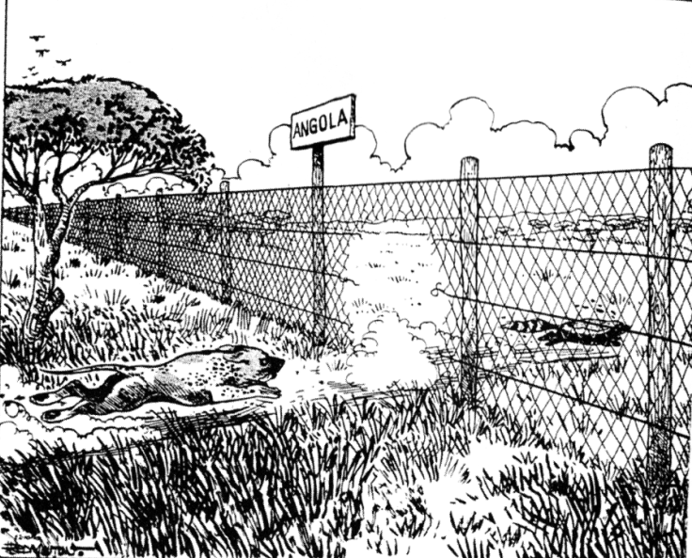

SOURCE 2C The MPLA controlled the areas around Luanda. The FNLA had some support in the north-east and the backing of Zaire. UNITA controlled the southern areas with the support of the South African Defence Force. Map from the Learner’s Book, page 103.

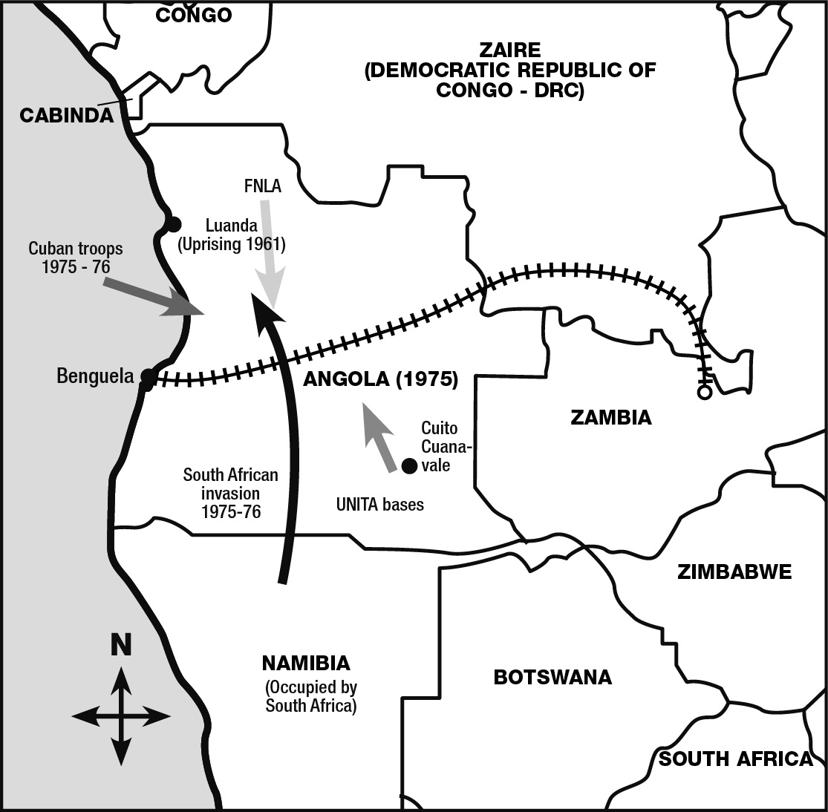

SOURCE 2D An an extract from an article posted on the free, online encyclopaedia – Wikipedia (written collaboratively by the people who use it) http://en.wikipedia.org/wiki/UNITA#Civil_war

The National Union for the Total Independence of Angola (UNITA) is the second-largest political party in Angola. Founded in 1966, UNITA fought alongside the Popular Movement for the Liberation of Angola (MPLA) in the Angolan War for Independence (1961–1975) and then against the MPLA in the ensuing civil war (1975–2002). The war was one of the most prominent Cold War proxy wars, with UNITA receiving military aid from the United States and South Africa while the MPLA received support from the Soviet Union and its allies. After the Portuguese withdrawal from Angola in 1974-75 and the end of their colonial rule, the MPLA and UNITA splintered, and civil war began as the movements clashed militarily and ideologically. MPLA leader Agostinho Neto became the first president of post-colonial Angola. Backed by Soviet and Cuban money, weapons and troops, the MPLA defeated the FNLA militarily and forced them largely into exile. UNITA also was nearly destroyed in November 1975, but it managed to survive and set up a second government in the provincial capital of Huambo. UNITA was hard-pressed but recovered with South African aid and then was strengthened considerably by US support during the 1980s. The MPLA’s military presence was strongest in Angolan cities, the coastal region and the strategic oil fields. But UNITA controlled much of the highlands interior, notably the Bié Plateau, and other strategic regions of the country. Up to 300,000 Angolans died in the civil war.

SOURCES FOR QUESTION 3: CIVIL SOCIETY PROTEST
[Focus: Role, impact and influence of Martin Luther King Jr]

SOURCE 3A According to figures from the US Census Bureau (August 2010), African-Americans comprise 12.9% of the US population but they have 37,9% of the abortions. From http://www.jillstanek.com/2011/01/mlk-day-observance-abort-not-by-the-color-of-their-skin/

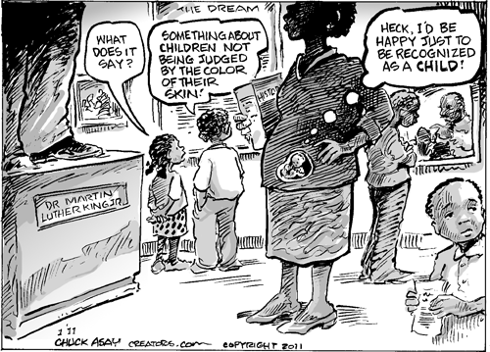

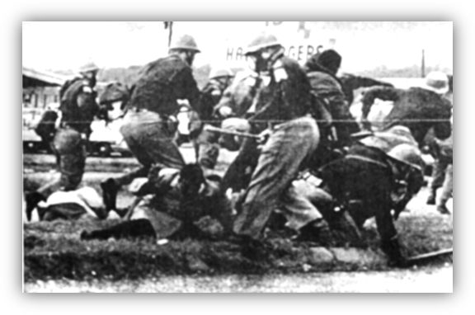
SOURCE 3B This photograph was taken during the Freedom Riders protest in the south of the USA during 1961. These Freedom Riders went to the South to support the fight against inequality. They were met with violence by the local people and police. Some of the Freedom Riders were killed, with white juries letting their murderers go free. Photographer − unknown.

Source 3C This is an extract from Martin Luther King Jr.’s ‘I have a dream’ speech and the photograph of the Washington March found in Michael Scott-Baumann, The USA since 1919, Mathew Arnold (1986), London, page 49

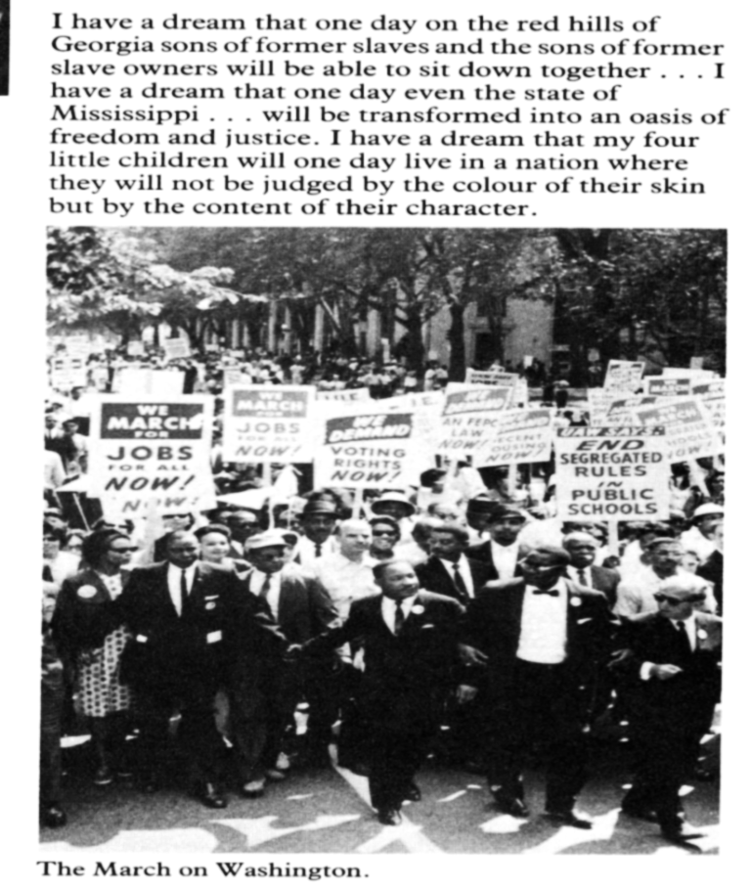

SOURCE 3D The following is an extract from a speech made by the American President in 1964.

So will you join in the battle to give every citizen the full equality which God enjoins and the law requires, whatever his belief, or race, or the colour of his skin?
Will you join in the battle to make it possible for all nations to live in enduring peace – as neighbours and not as mortal enemies?

