ADDITIONAL EXEMPLAR MID-YEAR
EXAMINATION PAPER 2
(TOPICS 4 and 5)
TIME: 2½ hours

MARKS: 100

Instructions:
1 This question paper consists of FOUR questions.
Questions 1 and 3: Civil resistance in South Africa 1970s to1980s
Questions 2 and 4: The coming of democracy in South Africa
2 Questions 1 and 2 are source-based questions.
3 Questions 3 and 4 are essay questions.
4 Each question is worth 50 marks.
5 You must answer ONE source-based and ONE essay question.

SECTION A: SOURCE-BASED QUESTIONS
Choose ONE question from Section A. Refer to the sources in the Addendum to answer the questions in Section A.

QUESTION 1: CIVIL RESISTANCE IN SOUTH AFRICA 1970s TO 1980s
[Focus: The Soweto uprising]

Key question: What were the causes and the significance of the Soweto uprising?

Study Source 1A and answer these questions:
1.1 Use Source 1A to identify two problems in the education of black learners that already existed the 1960s. (Substantiate your answer with evidence from the source.) (2×2) (4)
1.2 Use your understanding of the historical context and the information in the source to explain why no new schools were built in Soweto in the 1960s. (2×2) (4)
1.3 According to Source 1A, why did the numbers of school children increase between 1972 and 1976? (2×1) (2)
1.4 According to Source 1A, how is it clear that the government’s education policy in 1975 was based on race? (2×1) (2)
1.5 The source refers to Black Consciousness philosophies. In your own words explain what Black Consciousness was and how it changed people’s approach to their oppression. (4×2) (4)
1.6 Does Source 1A say that the actions of school students were a result of Black Consciousness? Explain your answer by referring to the source and by showing your understanding of how students became organised. (5×1) (5)

Read Source 1B and 1C answer these questions:
1.7 Identify four different ways, mentioned in the first paragraph of Source 1B and in Source 1C, that the government restored ‘law and order’ after the uprising? (4×2) (8)
1.8 The information given by Sonto and Kathrada in Source 1C is called oral evidence. It is based on their experiences and memories of the time. What is the value and what are the limitations of oral evidence as a source of information in history? (2×2) (4)
1.9 How does Source 1C back up the argument given in Source 1B about how the Soweto Uprisings was significant? (Include details from Source 1C in your answer.) (3×2) (6)

Study Source 1D and then answer this question:
1.10 Who created Source 1D and how does this influence their interpretation of the significance of the Soweto Uprising? (2×2) (4)

Use Sources 1A, 1B and 1C to answer these questions. All three sources are to be found on the internet.
1.11.1 Why must a researcher be cautious about the reliability of information found on the internet? (3×1) (3)
1.11.2 Looking specifically at who created and maintains these three sites, can you assess whether they are reliable evidence to use to find out about the Soweto Uprising? (Hint look at the information about the site in the captions.) (2×2) (4)
[50]

QUESTION 2: THE COMING OF DEMOCRACY IN SOUTH AFRICA
[Focus: The Truth and Reconciliation Commission]
Key question: How did the TRC help the process of reconciliation, justice and forgiveness?

Study Source 2A and answer these questions:
2.1 Identify two crucial things that Source 2A says came out of the Truth and Reconciliation Commission. (2×3) (6)
2.2 Explain how the TRC ‘produced an archive’ as stated in Source 2A. (2×1) (2)

Study Source 2B and answer these questions:
2.3 According to Source 2B, in what way was testifying a valuable process for perpetrators? (2×1) (2)
2.4 Explain why Source 2B is a useful source of information about the TRC. [Hint: comment on who wrote the source and his relationship to the TRC, and what he says about the TRC.] (2×2) (4)

Study Source 2C and answer these questions:
2.5 What, according to Source 2C, were two things that people were angry about? Use your own words to explain your answer. (2×2) (4)
2.6 Why do you think the makers of the film referred to in Source 2C called it Long Night’s Journey into Day? Use your own understanding of the TRC process to assess how appropriate you think this name is. (3×2) (6)
Study Source 2D and answer these questions:
2.7 Study Source 2D. What do the skulls and other objects lying on the floor represent? Refer to some of the visual clues in your answer. (4×1) (4)
2.8 The figure on the right in the cartoon is Archbishop Desmond Tutu. What is the cartoonist suggesting by portraying him in this way? Refer to details of the cartoon in your answer. (4×1) (4)
2.9 Explain the body language of the two figures standing in the middle of the cartoon. (2×2) (4)

Study Source 2E and answer these questions:
2.10 According to Source 2E, why did the Freedom Front reject the idea of a single national identity for all South Africans? (1×2) (2)
2.11 Explain why and how Source 2E presents a biased view of the TRC. (2×2) (4)

Use all the sources and your own knowledge:
2.12 Why is it important for historians to know about and examine different attitudes to the TRC process? Your answer will be marked according to this table: (8)

Level | The learner has: | Marks out of 8
3 | Written a convincing argument combining evidence from the sources and analytical commentary about the nature of studying history | 6 – 8
2 | Written a fairly clear argument but has not used evidence from the sources convincingly | 4 – 5
1 | Written off the topic or / and has not extracted relevant information from the sources or / and uses confusing or inaccurate expression which undermines communication. | 1 – 3
[50]

SECTION B
Choose ONE question from Section B. Your essay should be 900−1 000 words.

QUESTION 3: CIVIL RESISTANCE IN SOUTH AFRICA 1970s TO 1980s
Explain in what ways the UDF, the trade unions and community structures were the main players in organising resistance against the apartheid state in the 1980s. [50]

QUESTION 4: THE COMING OF DEMOCRACY IN SOUTH AFRICA
Explain the ways in which the leaders of the political parties had to make many compromises and concessions to ensure that a negotiated settlement was reached. [50]

ADDITIONAL EXEMPLAR
MID-YEAR EXAMINATION PAPER 2
ADDENDUM
SOURCES FOR QUESTION 1: CIVIL RESISTANCE IN SOUTH AFRICA 1970s TO 1980s
[Focus: The Soweto uprising]

SOURCE 1A An extract on the causes of the Soweto uprising from http://africanhistory.about.com/od/apartheid/a/Soweto-Uprising-Pt1.htm (accessed 22 August 2012). This website is part of the New York Times company.

Bantu Education did enable more children in Soweto to attend school than the old missionary system of education, but there was a severe lack of facilities. Overcrowded classrooms were used on a rota basis. There was also a lack of teachers, and many of those who did teach were under-qualified. In 1961, only 10 per cent of black teachers held a matriculation certificate.
Because of the government’s homelands policy, no new high schools were built in Soweto between 1962 and 1971 − students were meant to move to their relevant homeland to attend the newly built schools there. Then in 1972 the government gave in to pressure from business to improve the Bantu Education system to meet business’s need for a better trained black workforce. 40 new schools were built in Soweto. Between 1972 and 1976 the number of pupils at secondary schools increased from 12,656 to 34,656. One in five Soweto children were attending secondary school.
In 1975 South Africa entered a period of economic depression. Schools were starved of funds − the government spent R644 a year on a white child’s education but only R42 on a black child.
The African Students Movement, founded in 1968 to voice student grievances, changed its name in January 1972 to the South African Students Movement (SASM) and pledged itself to building a national movement of high school students who would work with the Black Consciousness (BC) organisation at black universities, the South African Students’ Organisation (SASO). This link with BC philosophies is significant as it gave students an appreciation for themselves as black people and helped politicise students.
So when the Department of Education issued its decree that Afrikaans was to become a language of instruction at school, it was into an already volatile situation. Students objected to being taught in the language of the oppressor. Many teachers themselves could not speak Afrikaans, but were now required to teach their subjects in it.

SOURCE 1B An extract from http://libcom.org/history/1976-the-soweto-riots explaining the significance of the Soweto Uprising. (libcom.org describes itself as ‘a resource for all people who wish to fight to improve their lives, their communities and their working conditions. We want to discuss, learn from successes and failures of the past and develop strategies to increase the power we, as ordinary people, have over our own lives.’)

Realising the scale that these riots were happening on, the government reacted in the way any government would: with the full use of organised violence. Anti-riot units along with armed vehicles and personnel were sent to Soweto and other townships. Government officials restricted the activities of different black and anti-apartheid groups. Meetings were stopped and activists were harassed. For instance, the radical black consciousness activist Steve Biko was ‘banned’ meaning he was stopped from making speeches in public and was not allowed to be quoted in print. In the end, due no doubt largely to his disregard for this law, he was killed by the police in a brutal beating.
But regardless of their actions, the government could not stop additional protests. They had lit a fire in the South African youth that could not be put out. The conflict about language had led to many students getting kicked out of school (or not having a school to go to). With no school to go to, over a quarter of a million children had a great deal of time on their hands leading to trouble in the streets daily. After Soweto, an uprising or march would take place almost every day, often completely spontaneously. Young blacks expressed their anger at apartheid by marching, rioting and setting fire to government property.
Over 360 blacks were killed in the Soweto riots of 1976. The South African government basically declared war on black school children. The government used their full physical force against the students but they did not let up. They carried on fighting and eventually the South African apartheid regime fell.

SOURCE 1C An extract from a website which is called ‘Overcoming apartheid’. It is compiled by Michigan State University in the USA. The website is http://overcomingapartheid.msu.edu/sidebar.php?id = 5&page = 3

The student uprising marked a decisive turning point in the history of the anti-apartheid struggle. Roseberry Sonto, an activist in Cape Town at the time, regarded the student uprising as a ‘gift’ that reinvigorated organizing efforts: ‘That was after which we started lots of things like bus boycotts, rent boycotts, meat boycotts − all kinds of boycotts just to drive the point home.’
The student uprising of 1976 was recognised as a watershed by the previous generation of activists. Ahmed Kathrada, convicted in the Rivonia Trial and imprisoned on Robben Island since 1964, learned of the student activism only in August when student leaders began to be sent to the Island. Then he and other prisoners understood its significance: ‘Especially after our sentence in 1964, the rest of the ‘60s was fear among the people… End of ‘69, the Black Consciousness movement came in, and the beginning of the ‘70s there was a revival of the trade union movement, so that gave us hope that things are changing. But come ‘76, when the students of Soweto came into the streets unarmed and they were killed in the hundreds – nobody knows how many of them were killed – that changed history. Fear was now driven out.’
The politicisation and activism of young South Africans in Soweto and beyond galvanised the liberation movements and set in motion a series of transformations that ultimately led to the demise of apartheid.

SOURCE 1D An ‘underground’ ANC news-sheet, Vukani-Awake, published in July 1976, praises the actions of the youth and points out the power of mass action. (Quoted in Hirson Baruch, Year of Fire, Year of Ash: The Soweto Revolt: Roots of a Revolution, Zed, London, 1979, page 200)

Our youth understood that their protest would be met by massive police violence but were not intimidated. They have won a great political victory – the Vorster government has been compelled to drop the use of Afrikaans in schools. More important, they have demonstrated the power of the people and shown that mass protest remains an important part of the liberation struggle.

SOURCES FOR QUESTION 2: THE COMING OF DEMOCRACY IN SOUTH AFRICA
[Focus: The Truth and Reconciliation Commission]
How did the TRC help the process of reconciliation, justice and forgiveness?

SOURCE 2A An historian, K. Christie,comments on the achievements of the Truth and Reconciliation Commission (TRC). From K. Christie, the South African Truth Commission, Palgrave, 2000, page 176-7

There are two crucial things that have come out of the South African Truth and Reconciliation Commission. The first is that it has achieved a remarkable and far-ranging public exposure of the human rights violations and crimes committed under the apartheid regime…It has forced a previously reluctant population (though, of course, there is still denial at one level) to see that apartheid was morally indefensible; that it’s a crime against humanity. It has produced an archive which allows people to examine their past and hopefully learn from it.
Secondly, it has allowed ordinary people to find expression for the suffering under the regime. It has had a completely cathartic function for many of the victims…It is in this sense that some form of reconciliation has already taken place.

SOURCE 2B Piet Meiring, a TRC Commissioner, analyses the complexity of the process. From P. Meiring, Chronicles of the Truth Commission, Carpe Diem Books, 1999, page 372−3

Was it worth it to come forward? For perpetrators who lived under a cloud for years, the process meant a new life! From the side of some high-profile families of victims there were serious objections. The Biko, Mxenge and Goniwe families, from the Eastern Cape, saw the process as extremely unfair towards the victims. They felt so strongly about it that they fought the amnesty legislation right up to the Constitutional Court. Whether the TRC with its reparation measures will succeed in making it clear to everyone that the gracious amnesty offer to perpetrators is balanced by an equally gracious compensation to victims, remains to be seen. The nation will have to be convinced that the process is as ‘victim-friendly’ as it is ‘perpetrator-friendly’.

SOURCE 2C An extract from an interview with Frances Reid, the American director/producer of the film Long Night’s Journey into Day: South Africa’s Search for Truth and Reconciliation. (2000), 94 minutes, Director/Producer: Frances Reid, Director: Deborah Hoffmann, Distributed by California Newsreel

…apartheid security forces. As the story became increasingly complex, we incorporated those complexities into our filmmaking, while maintaining our initial vision of showing a nation and a people grappling with the heights and depths of their humanity.

SOURCE 2D A cartoon by Zapiro which was published by the Mail and Guardian in 1998. Image found in Wilhelm Verwoerd and Mahlubi ‘Chief’ Mabizela, Truths Drawn in Jest: Commentary on the Truth and Reconciliation Commission through Cartoons, David Philip, Cape Town, 2000, page 40.

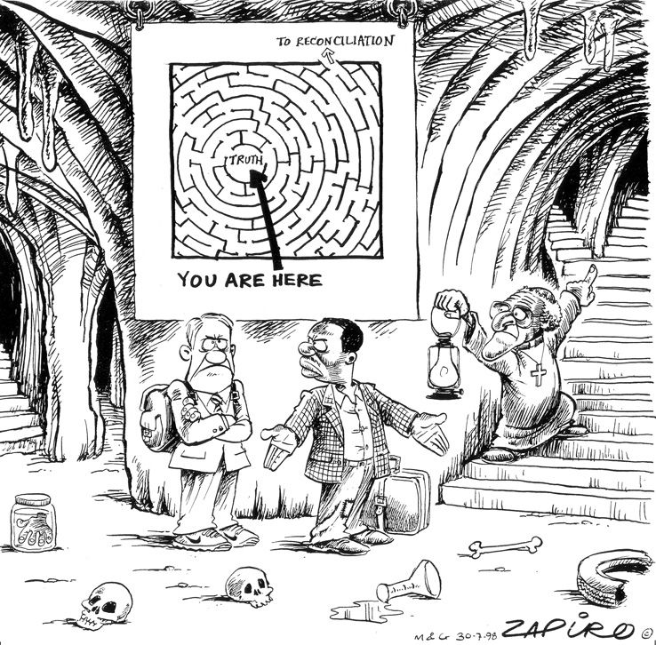

SOURCE 2E P.D. Uys states the views of the Freedom Front, representing right-wing Afrikaner opinion in 1998. (Quoted in K. Christie, The South African Truth Commission, Palgrave, 2000, page 109)

The ideal of the TRC to contribute to the ANC’s objective of building one nation, is an ANC inspired ideal. The ANC wants to build one nation out of a large variety of peoples and tribes. The previous president of Mozambique, Samora Machel, said ‘For the nation to survive, the tribe must die’. He was proved wrong – the nation can only survive if it allows the tribes to live and prosper, in harmony with each other.
We therefore oppose the concept of one nation; we don’t believe in it; one nation does not exist in this multiracial country, and the more the ANC forces its policies down the throats of the citizens, the more they object to ANC policies. The TRC seeks not only to give people a common memory; they want to re-write history… We will not accept their version of history.

