ADDITIONAL EXEMPLAR

MID-YEAR EXAMINATION PAPER 1
(TOPICS 1 and 3)

TIME: 2 ½ hours

MARKS: 100

Instructions:
1 This question paper consists of FOUR questions.
Questions 1 and 3: The Cold War
Questions 2 and 4: Civil Society Protests 1950s to 1970s
2 Questions 1 and 2 are source-based questions.
3 Questions 3 and 4 are essay questions.
4 Each question is worth 50 marks.
5 You must answer ONE source-based and ONE essay question.

SECTION A: SOURCE-BASED QUESTIONS
Choose ONE question from Section A. Refer to the sources in the Addendum to answer the questions in
Section A.

QUESTION 1: THE COLD WAR
[Focus: The Cuban Missile Crisis]
Key question: What were the different views of the Cuban Missile Crisis?

Study Source 1A and answer these questions.
1.1 Use the information in Source 1A and your own understanding of the situation to explain what caused Castro to ‘declare himself a communist’? Quote phrases from the source to support your answer. (3×1) (3)
1.3 Use your understanding of the situation in Cuba to explain why the writer refers to Castro as a ‘left-wing nationalist’. (2×2) (4)
1.4 Does Source 1A give a neutral explanation of the reasons for the end of the Cuban Missile Crisis? Explain your answer. (3×1) (3)

Study Source 1B and answer these questions:
1.5 The tree on the left shows some of the countries in which the USA had missile bases. Briefly explain what the cartoonist is suggesting by showing both leaders wanting to ‘prune’ the branches hanging over their side of the garden? (2×2) (4)
1.6 What is the cartoonist suggesting by showing the Cuban branch as a small one, compared to the larger branches on the other tree? (4×1) (4)
1.7 Do you think the cartoonist is critical of, or sympathetic towards, the American viewpoint? Refer to the cartoon in your answer. (5×1) (5)

Study Source 1C and answer these questions:
1.8 According to Source 1C, for what reasons did the Soviets get involved in Cuba? (3×2) (6)
1.9 Suggest why Sources 1A and 1C give such different interpretations of the Cuban Missile Crisis. (2×3) (6)
1.10 Assess how effectively these three sources illustrate the military and ideological competition typical of the Cold War period. Your paragraph should be carefully argued and well-structured, with information extracted from each source. Your answer will be marked according to the table that follows. (9)

Level | The learner has: | Marks out of 9
3 | Shown an understanding of the military and ideological competition. Answer has synthesised the relevant issues that are reflected in the three sources and made a convincing argument. Answer is a well-crafted paragraph and the expression is clear and accurate. | 7 – 9
2 | Identified some of the relevant points from the sources but has made an unconvincing argument. Expression and paragraph structure have some errors. | 4 – 6
1 | Misinterpreted the sources and not identified relevant information. Learner shows very little or no understanding of the issues involved. Little attempt to structure a paragraph or write accurately. | 1 – 3

QUESTION 2: CIVIL SOCIETY PROTESTS 1950s TO 1970s
[Focus: The Civil Rights and Black Power Movements in the USA]
Key question: What was the nature of the Civil Rights and Black Power protest movements?

Study Source 2A and answer these questions.
2.1 Use the information in Source 2A to describe the nature of the resistance used by the Civil Rights Movement. (4×1) (4)
2.2 According to Source 2A, is it accurate to view the Civil Rights Movement as a small group of intellectuals? Quote from the source to back up your view. (4×1) (4)
2.3 Does the writer of Source 2A show any bias towards the Civil Rights Movement? Extract information from the source to support your answer. (6×1) (6)
2.4 According to the information in these sources, what conduct or tactics did King believe would achieve positive results for the Civil Rights Movement? Quote from the sources to support your answer. (5×1) (5)
Study Source 2B and 2C and answer these questions.
2.5 How useful are Sources 2B and 2C as evidence of the tensions in American society at that time? (4×1) (4)

Study Source 2D, 2E and 2F and answer these questions.
2.6 In what ways was ‘Black Power’ a cultural movement? Use evidence from Source 2D to support your answer. (5×1) (5)
2.7 What evidence is there in Source 2D to support or oppose the view that ‘Black Power’ was an extremist viewpoint? (4×1) (4)
2.8 Use the information in Sources 2D, 2E and 2F to explain why many African Americans were attracted by the ideas of Malcolm X. (2×3) (6)
2.9 Using information from several sources, explain how Martin Luther King and Malcolm X differed in their attitudes towards whites. (8)

Your answer will be assessed according to this rubric:

Level | The learner has: | Marks out of 8
3 | Written a succinct and insightful synopsis of the ideas of both men and has effectively integrated information from several sources. The paragraph is articulate and well-structured. | 7 – 8
2 | Written a clear and accurate synopsis of the ideas of both men and has used some information from the sources. | 4 – 6
1 | Written a disjointed paragraph with an inconsistent or incorrect synopsis of the men’s ideas. Little reference is made to the sources or they are used inappropriately and ineffectively. | 1 – 3

2.10 Many of sources used in this question are extracts from speeches. Does this make them reliable sources of evidence about the Civil Rights and Black Power protests? (2×2) (4)
[50]

SECTION B: ESSAY QUESTIONS
Choose ONE question from Section B. Your essay should be about 900–1 000 words.

QUESTION 3: THE COLD WAR
[Focus: China or Vietnam]
3.1 To what extent was China’s relationship with its neighbours a troubled one? (Use evidence about China’s relations with two neighbouring states to support your answer). [50]

OR
3.2 Explain how the war in Vietnam started as an anti-colonial struggle but became prolonged and more deadly as a result of being drawn into the Cold War political arena. [50]

QUESTION 4: CIVIL SOCIETY PROTESTS 1950s TO 1970s
[Focus: Comparison of the Civil Rights and Black Power Movements]
The non-violent protests of the Civil Rights Movement were more successful than the militant approach of the Black Power movement. To what extent is this an accurate assessment of the struggle for racial equality in the United States in the 1960s? [50]

ADDITIONAL EXEMPLAR
MID-YEAR EXAMINATION PAPER 1
ADDENDUM

SOURCES FOR QUESTION 1: THE COLD WAR

What were the different interpretations of the Cuban Missile Crisis?

SOURCE 1A A commentary on the Cuban Missile Crisis written by a British historian, R.D. Cromwell, and published in his book World History in the 20th Century, Longman, London, 1969 (Quoted in Peter Mantin, Questions of Evidence, Hutchinson Educational, London, 1987, page 56)

In 1958, Fidel Castro, a left-wing nationalist, came to power in Cuba. A series of radical measures led to opponents of his regime going to the USA. In April 1961 these Cuban refugees invaded Cuba with the open moral support of Kennedy’s government, and were completely defeated in the Bay of Pigs. Thereafter Castro declared himself a communist and received considerable military and economic aid from the communist bloc. In 1962 the USA discovered and photographed a number of offensive surface-to-surface missile bases in Cuba. These communist missile bases represented a major threat to American security. Kennedy, therefore, ordered an American naval blockade of Cuba. For a few days the world seemed on the verge of a major nuclear war. But Khrushchev gave way; he agreed to the withdrawal of the missiles and the dismantling of the bases.

SOURCE 1B A British cartoon, published on 17 October 1962 in Punch magazine, at the time of the Cuban Missile Crisis, shows Kennedy on the left and Khrushchev on the right. The titles of the books they are reading are ‘Hints on Pruning’

. 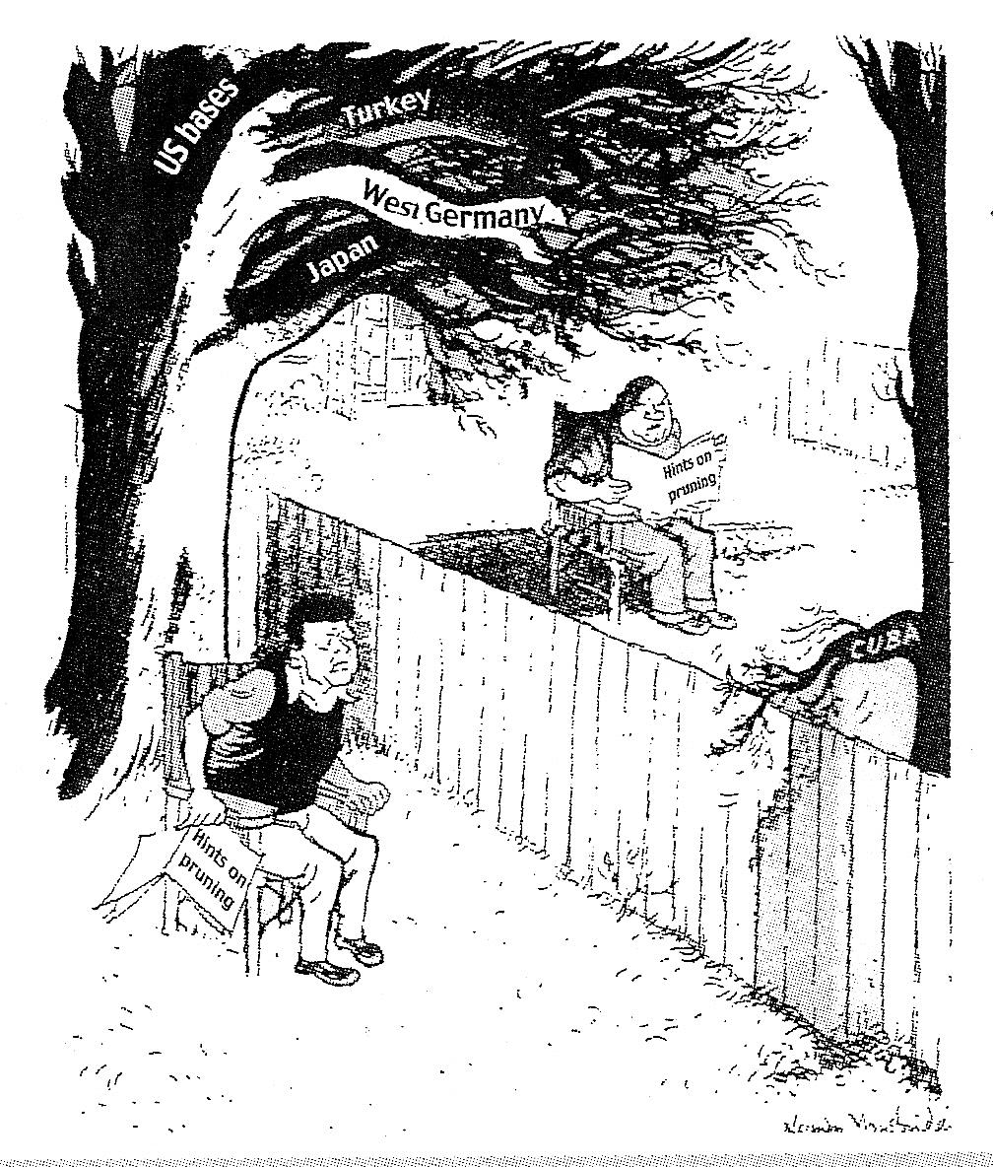

Over the Garden Wall

SOURCE 1C A Soviet view of the Cuban Missile Crisis from the memoirs of Nikita Khrushchev, Khrushchev Remembers, Little Brown and Company, New York, 1970, pages 545−546.

After Castro’s crushing victory over the counter-revolutionaries, we intensified our military aid to Cuba… we were quite sure that the Americans would never get used to the existence of Castro’s Cuba. They feared, as much as we hoped, that a socialist Cuba might become a magnet that would attract other Latin American countries to socialism…. The fate of Cuba and the maintenance of Soviet prestige in that part of the world preoccupied me…. We had to find a way of stopping American interference in the Caribbean…. The logical answer was the missiles…. I had the idea of installing the missiles with nuclear warheads in Cuba without letting the United States find out they were there until it was too late to do anything about them. We had no desire to start a war.

SOURCES FOR QUESTION 2: CIVIL SOCIETY PROTESTS 1950s TO 1970s
What was the nature of the Civil Rights and Black Power protest movements?

SOURCE 2A An historian, Joe William Trotter, describes the protests by African Americans. From J.W. Trotter, The African American Experience, Houghton Mifflin, Boston, 2001, page 545.

Between the end of World War II and the mid-1960s, African Americans launched the largest and most successful mass movement for civil and human rights in the nation’s history. They moved their struggle from courts, presidential edicts, and congressional legislation to the streets. In rapid succession, they initiated boycotts, sit-ins, freedom rides, and voter education projects across the South. Although their actions were deeply rooted in local community-based institutions and organisations, they transformed such struggles into a broader national, and increasingly international, movement. Inspired by independence movements in Africa and Asia as well as their own history, culture and social struggles, African Americans used America’s Cold War advocacy of democratic freedoms abroad to demand their own civil rights.

SOURCE 2B This is an extract from Martin Luther King’s speech to an angry crowd who were reacting to the bombing of his house in Montgomery, Alabama, on 30 January 1955. The crowd had gathered around his house, armed with guns, rocks, knives, sticks and bottles. They wanted revenge and the situation was tense. (Quoted in Peter Mantin, Questions of Evidence, Hutchinson Educational, London, 1987, page 106.)

Don’t do anything panicky at all. Don’t get your weapons. He who lives by the sword will die by the sword. We are not advocating violence. I want you to love our enemies, and let them know you love them; I want it to be known across the land that if I am stopped, this movement will not stop and our work will not stop, for what we are doing is right.

SOURCE 2C These are extracts from the speech Martin Luther King made at the Lincoln Memorial during the 1963 march on Washington, attended by more than 250,000 people. From http://www.famous-speeches-and-speech-topics.info/martin-luther-king-speeches/martin-luther-king-speech-i-have-a-dream.htm [Date accessed: 1 September 2012]

1963 is not an end, but a beginning… there will be neither rest nor tranquillity in America until the Negro is granted citizenship rights. The whirlwinds of revolt will continue to shake the foundations of our nation until the bright day of justice emerges. But… in the process of gaining our rightful place we must not be guilty of wrongful deeds. Let us not seek to satisfy our thirst for freedom by drinking from the cup of bitterness and hatred… The marvellous new militancy which has engulfed the Negro community must not lead us to distrust all white people, for many of our white brothers, as evidenced by their presence here today, have come to realise that their destiny is tied up with our destiny and their freedom is inexplicably bound up with our freedom. We cannot walk alone.
SOURCE 2D An American historian, Paul Boyer, explains Black Power. From P. Boyer et al, The Enduring Vision: A History of the American People, D.C. Heath and Company, Lexington, 1996, page 980.

The ‘Black Power’ slogan was adopted by African-Americans of virtually every persuasion. Revolutionaries used it to preach guerrilla warfare; liberals, to demand reform; conservatives, to demand self-help. For many who adopted it, the phrase simply meant self-pride. ‘Say it loud – I’m black and I’m proud,’ chanted soul singer James Brown, and a generation of African-Americans affirmed that ‘black is beautiful’. Rejecting skin bleaches and hair straighteners, young blacks donned dashikis (berets), wore Afro hairstyles, enjoyed soul music and soul food, and established black studies programs at colleges. Black Power reflected an insistence that African-Americans shape their own culture and define their own destiny.

SOURCE 2E A supporter of Malcolm X, Ossie Davis, explains why he supported his philosophy in ‘Why I eulogise Malcolm X’. (Quoted in J. H Clarke (ed.), Malcolm X: The Man and his Times, Macmillan, London, 1969, page 128.)

We used to think that protocol and common sense required that Negroes stand back and let the white man speak up for us, defend us, and lead us from behind the scenes in our fight. This was the essence of Negro politics. But Malcolm said, ‘To hell with that! Get up off your knees and fight your own battles….’ He could make you as angry as hell, but he could also make you proud. It was impossible to remain defensive and apologetic about being a Negro in his presence.

SOURCE 2F Some African Americans, such as Malcolm X, argued that blacks should meet violence with violence. This is an extract from a speech he made to students in Mississippi in December 1964 called ‘To Mississippi Youth’. (The full speech is quoted in G. Breitman (ed.), Malcolm X Speaks: Selected Speeches and Statements, Grove Press, New York, 1965, pages 137–146.)

I don’t go along with non-violence unless everybody’s going to be non-violent. If they make the Ku Klux Klan non-violent, I’ll be non-violent…. But as long as you’ve got somebody else not being non-violent, I don’t want anybody coming to me talking any non-violent talk.
You get your freedom by letting your enemy know that you’ll do anything to get your freedom; then you’ll get it. It’s the only way you’ll get it… fight them, and you’ll get your freedom.

